**PROJECT REPORT**

# **Deploy A Three-tier Web Application on Aws**

# **Title:**

# Deploy A Three-tier Web Application on Aws

# **Abstract**:

The abstract provides an overview of the three-tier architecture, which consists of the presentation tier, application tier, and data tier. Each tier is responsible for specific functionalities, allowing for separation of concerns and improved maintainability. The abstract then outlines the steps involved in deploying a three-tier web application on AWS. It begins with setting up the necessary infrastructure components, such as Amazon Elastic Compute Cloud (EC2) instances for hosting the web servers and Amazon Relational Database Service (RDS) for managing the database layer. It also covers the configuration of Amazon Virtual Private Cloud (VPC) to ensure secure communication between the tiers. Furthermore, the abstract highlights the use of AWS Elastic Load Balancer (ELB) for distributing traffic across multiple web servers, enhancing application performance and availability. It explores the scalability aspect by introducing AWS Auto Scaling, which automatically adjusts the number of EC2 instances based on predefined metrics. The abstract also discusses the importance of security considerations and demonstrates how to implement security measures using AWS Identity and Access Management (IAM), security groups, and network ACLs. Additionally, the abstract touches upon best practices for monitoring and logging using AWS CloudWatch, which allows for real-time monitoring of resources, application performance, and overall system health. By following the guidelines presented in this abstract, developers can successfully deploy a highly available, scalable, and secure three-tier web application on AWS. This abstract serves as a starting point for further exploration and implementation of the three-tier architecture on AWS, enabling developers to build robust and resilient web applications.

***Contents***

**Deploy A Three-tier Web Application on Aws** 1

**Title:** 1

Deploy A Three-tier Web Application on Aws 1

**Abstract**: 1

**CLOUD COMPUTING** 4

**How does cloud computing work?** 5

**Examples of cloud computing?** 6

**Why is it called cloud computing?** 6

**History of cloud computing** 7

**Top benefits of cloud computing** 7

**1.** **Cost** 7

**2.** **Speed** 7

**3.** **Global scale** 7

**4.** **Productivity** 7

**5.** **Performance** 8

**6.** **Reliability** 8

**7.** **Security** 8

**1.** **Public cloud** 8

**2.** **Private cloud** 8

**3.** **Hybrid cloud** 8

**Types of cloud services: PaaS, IaaS, SaaS, and Serverless** 9

**1.** **Software as a service (SaaS)** 9

**2.** **Platform as a service (PaaS)** 9

**3.** **Infrastructure as a service (IaaS)** 10

**4.** **Serverless computing** 11

**Uses of cloud computing** 11

**Create cloud-native applications** 12

**Test and build applications** 12

**1.** **Backup, Store, and recover data** 12

**2.** **Analyze data** 12

**3.** **Stream audio and video** 12

**4.** **Embed intelligence** 12

**5.** **Deliver Software on demand** 12

**INTRODUCTION OF AWS** 13

**Overview of AWS** 13

**History of AWS** 14

**Who Uses AWS?** 15

**Why is AWS so Successful?** 16

**The Future of AWS** 17

**Advantages of Amazon Web Services** 18

**Why Use AWS?** 18

**1.** **Improved Security** 18

**2.** **Cost-Effectiveness** 19

**3.** **Flexibility and Openness** 20

**4.** **Scalability and Elasticity** 20

**Illustrating Scalability- Low demand vs. high demand** 21

**Illustrating elasticity- Low demand vs high demand** 21

**Services of AWS** 21

**Services provided by AWS** 21

**The Computer Services** 21

**The Storage Services** 22

**The Database Services** 22

**The Migration Services** 22

**The Networking and Content Delivery Services** 22

**The Management Tools** 22

**The Security & Identity, Compliance Services** 22

**Messaging Services** 22

**Amazon Web Services Storage Services** 24

**Amazon Web Services Databases** 24

**HOW TO SIGN UP ON AWS** 26

**IMPLEMENTATION** 27

**ARCHITECTURE:** 27

**HOW I DEPLOYED A THREE-TIER WEB APPLICATION ON AWS:** 28

**CLOUD COMPUTING**

**What is cloud computing?**

In simple terms, Cloud computing is the distribution of on-demand computing services – from apps to storing and power processing, usually through the web and based on pay-as-you-go. It is the on-demand delivery of IT resources via the internet with pay-as-you go pricing, instead of buying, owning and maintaining physical data centers and servers, you can access technology services such as computing power, storage and database on an hours needed bases from a cloud provider like Amazon Web Services. Organizations of every size, types and industry are using cloud for a wide variety of cases such as data backup, disaster recovery, email, virtual desktops, software development and testing and customer-based web applications. For example, health care companies are using the cloud to develop more personalized treatment for patients, financial services companies are using the cloud to power real-time fraud detection and prevention and video game makers are using the cloud to deliver online games to millions of players around the world. With cloud computing, your business can become more agile, reduced cost, instantly scaled, and deploying globally in minutes. It gives you instant access to a broad range of technologies so you can innovate faster and there will be anything you can’t imagine from infrastructure services such as compute storage and databases, data analytics to data analytics and lot more. You can deploy technological services in a matter of minutes and get ideas. It gives you the freedom to experiment and testing ideas to differentiate customer’s experiences and transform your business such as adding machine learning and intelligence to your apps in order to personalize experience for your customers and improve their engagements. You don’t need to make large up- front investments and hardware and over pay for capacity you don’t use instead you can trade capital expense for variable expense and only pay for IT as you consume it.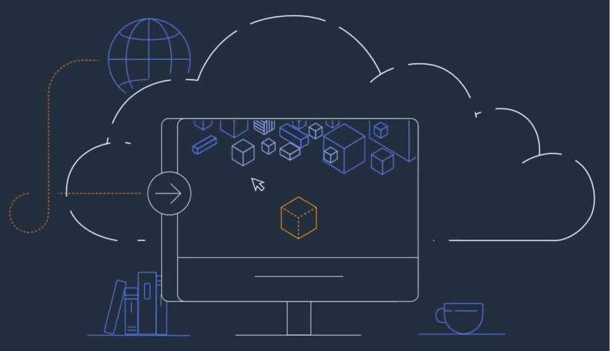

**How does cloud computing work?**

Instead of maintaining a personal computing structure or data centers, an organization can access anything from apps to storage from a provider of cloud service.

An advantage of using cloud computing services is that companies may dodge the cost ahead and difficulty owning and sustaining their own IT infrastructure, but instead pay for whatever they use, anytime they use it.

Sequentially, cloud computing services providers can gain from vital economies of scale by distributing similar services to more customers.

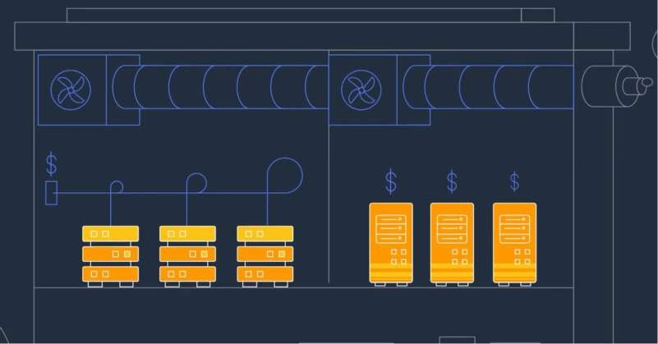

**Examples of cloud computing?**

Cloud computing supports a wide range of services. It includes customer service

such as Gmail or the cloud back-up of photos from your mobile phone, still to the services that enable large enterprises in hosting all their data while running apps in the cloud. Netflix depends on cloud computing services in running its video streaming service and its other business systems and having a total number of other companies.

Cloud computing is suitable for the original selection for several applications: software vendors are progressively giving their apps as services through the web instead of different products as they attempt to move to a subscription model. Nevertheless, there is still a possible downside to cloud computing, being that it can also bring in new risks and costs for firms using it.

**Why is it called cloud computing?**

A vital model backing up cloud computing is that where the service is located and other details like the operating system or hardware in which it is running, it is considered unnecessary to the user. With this in mind, the symbol of the cloud was hired from ancient telecoms network plans. The public telephone network (and advanced to the internet) was frequently symbolized as a cloud to signify that the doesn't matter – it was only a cloud of stuff.

This is, of course, an excessive simplification; for a lot of customers, locating their services and data is still a primary issue.

**History of cloud computing**

As a term, Cloud computing has been existing since the early 2000s. Still, then, the idea of computing-as-a-service has been everywhere for much, very long, dating back to the 1960s, wherein computer bureaus agencies would enable firms to rent time on a mainframe instead of having a person buy one.

The Personal Computer's rise replaced such 'sharing-time' service, making a computer very much affordable. In turn, by the increase of business data centers where organizations would stock vast amounts of data.

But the idea of renting access to the power of computing has reemerged again and again – in the app service suppliers, grid computing as well as utility computing of the early 2000s and late 1990s. This was accompanied by cloud computing, which took a grip with software development as a service and hyper- scale cloud computing suppliers like AWS.

**Top benefits of cloud computing**

Cloud computing is an excellent change from the outdated system business thinking about IT resources. Below are collective reasons motive firms are switching to cloud computing services:

1. **Cost**

Cloud computing removes the capital cost of purchasing software and hardware while setting up and running on-site datacenters—the stands of servers, the round-the-clock energy for power and chilling, and the IT specialists for handling the infrastructure. It improves quickly.

1. **Speed**

Many cloud computing services are given self-service and based on demand. Therefore, even vast sums of computing resources can be provided in no time, generally with only a limited mouse click, giving organizations room for elasticity and taking the burden off capability planning.

1. **Global scale**

An advantage of cloud computing services is the capacity to measure elasticity. In cloud speak, it has to do with distributing the exact amount of IT resources – for instance, additional or fewer computing power, bandwidth, storage right where required, and from the same geographical location.

1. **Productivity**

Typically, on-site data centers need a lot of “stacking and racking” – software patching, hardware setup, and other time-consuming IT management chores. Cloud computing eradicates the necessity for many such tasks, so IT teams would spend time getting more important business goals.

1. **Performance**

The most extensive cloud computing services work on a worldwide network of protected data centers that are often improved to the newest quick and effective computing hardware. It gives numerous advantages over a particular corporate data center and limited network inactivity for apps, and better economies of scale.

1. **Reliability**

Cloud computing enables backing up of your data, tragedy retrieval, and business stability easier and at a reduced amount because data can be reflected at several redundant sites on the cloud provider’s network.

1. **Security**

A lot of cloud providers give a wide range of controls, technologies, and policies that supports your safety position

Many cloud providers offer a broad set of guidelines, technologies, and rules that strengthen your security posture overall, helping protect your data, apps, and infrastructure from potential threats.

**Types of cloud computing**

Not all clouds are the same, and not a kind of cloud computing is right for everyone. Several different models, classes, and services have evolved to offer the right solution for your needs.

First, you need to determine the type of cloud deployment, or cloud computing architecture, that your cloud services will implement. There are three different ways to deploy cloud services: on a public cloud, private cloud, or hybrid cloud. Learn more about public, private, and hybrid clouds.

1. **Public cloud**

Public clouds are owned and operated by third-party cloud service providers, which deliver their computing resources, like servers and storage, over the Internet. Microsoft Azure is an example of a public cloud. With a public cloud, all hardware, software, and other supporting infrastructure is owned and managed by the cloud provider. You access these services and manage your account using a web browser. Learn more about the public cloud.

1. **Private cloud**

A private cloud is a cloud computing resource used by one firm or business organization. It can be situated on a firm’s on-site datacenter. Several firms also pay third-party service providers to host their private cloud. A private cloud is one that such infrastructure and services are preserved on a reserved network.

1. **Hybrid cloud**

Hybrid clouds bring together private and public clouds, putting together technology that enables apps and data to be divided among them. By allowing apps and data to move amidst public and private clouds, a hybrid cloud offers your business the opportunity for flexibility, additional options for deployment and enables the enhancement of your current infrastructure, compliance, and security.

**Types of cloud services: PaaS, IaaS, SaaS, and Serverless**

Many cloud computing services can be found in four extensive groups: platform as a service (PaaS), infrastructure as a service (Iaas), software as a service, and serverless. They are normally called the cloud computing “stack” since they construct above each other. Knowing what they signify and how different they are shows how easier to achieve your organization’s goals.

1. **Software as a service (SaaS)**

It’s a technique for distributing software apps through the web, on-demand, and characteristically based on subscription. With SaaS, cloud providers manage and host the software app and fundamental infrastructure, handling all maintenance such as safety fixing and software upgrades. Users connect to an app through the internet, regularly with an internet browser on their tablet, PC, or phone and doesn’t have to be downloaded on your PC.

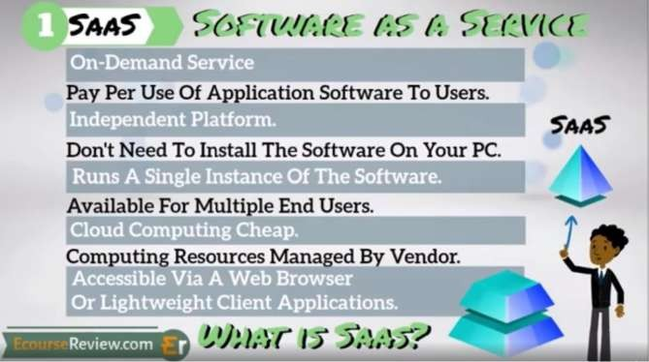

1. **Platform as a service (PaaS)**

This has to do with a cloud computing service supplying an on-demand atmosphere for managing software apps, developing, delivering, and testing. PaaS is planned to enable developers to have a more comfortable and quick way to make mobile applications or web, and not minding managing or setting up the fundamental infrastructure of network, databases, servers, and storage required for the development.

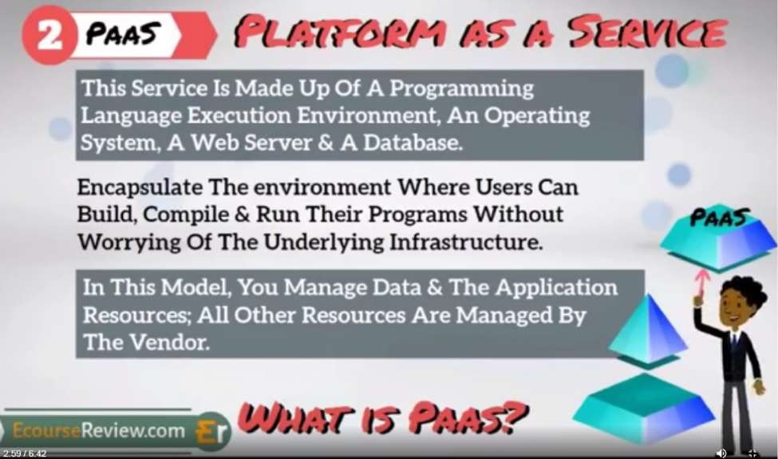

1. **Infrastructure as a service (IaaS)**

The most fundamental group of cloud computing services. With IaaS, you can rent IT infrastructure, virtual machines (VMs), and servers, including operating systems, networks, storage – from a cloud provider based on pay-as-you-go.

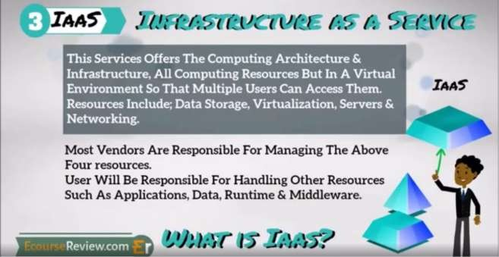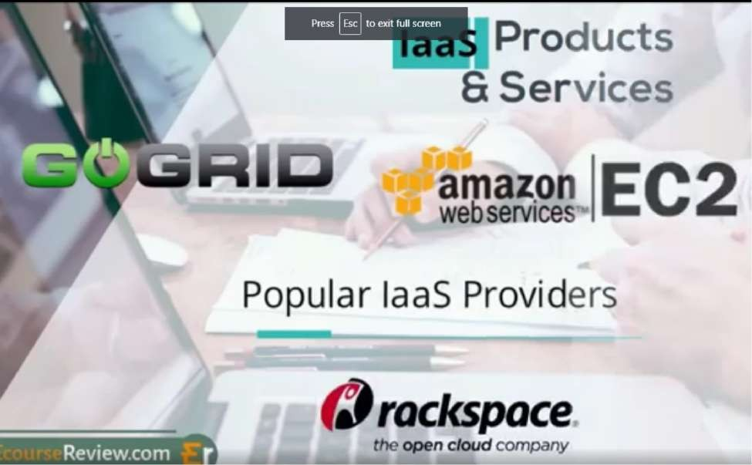

1. **Serverless computing**

Intersecting with PaaS, serverless computing concentrates on creating a working application without consistently managing the infrastructure and servers needed to do so. The cloud provider collects the capacity planning, setup, and server management for you. Serverless architectures are incredibly accessible and event-driven, only with resources while a particular function or trigger arises.

**Uses of cloud computing**

You may not consciously know that you’re using cloud computing right now, even if you’re not conscious of it.

Peradventure, you use an online service to edit documents, send an email, play games, watch movies or TV, or save photos and other files. It’s probably that

cloud computing is causing all to be possible behind the scenes. The primary cloud computing services are hardly a decade old. Still, previously a diversity of organizations – from little startups to worldwide corporations, government agencies to nonprofits – are taking up the developing tools for various reasons.

Below are uncommon instances of what’s likely possible today with cloud services from a cloud provider:

**Create cloud-native applications**

Swiftly deploy, construct, and scale apps—API, web, and mobile. Enjoy the benefits of cloud-native approaches and technologies, like containers, microservices architecture, Kubernetes, DevOps, and API-driven communication.

**Test and build applications**

Decrease time and cost for app development through cloud infrastructures that can simply be scaled up or down.

1. **Backup, Store, and recover data**

Safeguard your data on a more cost-efficient and massive scale when you transfer your data through the internet to an offsite cloud system that is reachable from anywhere and any device.

1. **Analyze data**

Unite your data through locations, divisions, and teams in the cloud. Then use cloud services like artificial intelligence and machine learning to reveal insight for more knowledgeable decisions.

1. **Stream audio and video**

You can be connected to your audience anytime and anywhere through any device with high-definition audio and video with worldwide distribution.

1. **Embed intelligence**

Use smart models to aid the engagement of customers while providing practical insights from the captured data.

1. **Deliver Software on demand**

Deliver Software on the market is also referred to as Software as a service (SaaS); on-demand Software allows you to offer the recent software versions and updates to customers—anytime they require it and anywhere they can be found.

**INTRODUCTION OF AWS**

**What is AWS?**

AWS means Amazon Web Services that is used by millions, and to get the answer to this question, we must know that AWS is a cloud provider. It is a safe cloud services platform that offers almost all that a business requires to develop sophisticated applications with reliability, scalability, and flexibility. It is a model for billing generally referred to as “pay-as-you-go,” having no upfront or capital cost. Amazon offers almost 100 services based on-demand, and the list has been rising daily. Operation is almost immediately, and it’s accessible with reduced setup.

To master AWS is not all about the online building of sites. The service affords developers access to an interconnected set of attributes offering calculated database storage, power, content delivery, and an increasing portfolio of connected functionality. Organizations around the globe use AWS to develop and scale. Cloud computing has come to remain, and the available solutions from AWS are fast-tracking its development.

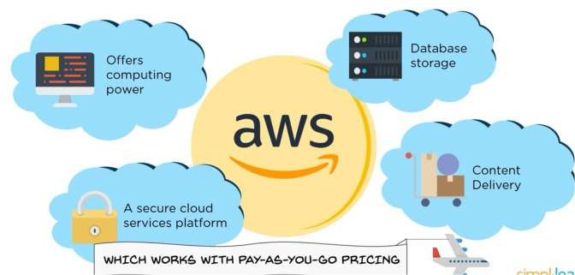

**Overview of AWS**

Cloud computing is now an essential part of all businesses in every industry. Amazon Web Services is a prevalent form that increases efficiency while assisting several business practices. Dating back to the 2000s, organizations depended absolutely on servers that are purchased servers. In contrast, such servers had functions that are limited with steep prices, including a server that is functioning requiring numerous validations.

The more business keeps experiencing growth, the more optimization practices and servers are needed. Getting such items showed unproductively and at times excessively costly.

The benefits of Amazon Web Services have been the answer to many problems. Organizations that use AWS have instantly available servers; also, AWS offers various improved storage options, workloads, and enhanced security measures.

**History of AWS**

Amazon Web Services was launched in 2002. The company intended to sell the infrastructure that is not in use as a service or offering it to customers, wherein the purpose was met enthusiastically. Amazon had its first AWS product launched in the year 2006. After four years, in the year 2012, Amazon had a huge occasion to gather customer input concerning AWS. To date, the organization continues to hold similar events, like Reinvent, that lets customers share feedback concerning AWS.

In 2015, Amazon publicized that the revenue of AWS has amounted to $7.8 billion. From then and 2016, measures had been launched by AWS aiding customers to migrate their services to AWS. Such actions, including the growing and appreciating features of AWS, made further economic growth. In the year 2016, Amazon’s revenue augmented to $12.2 billion in 2016. Presently, AWS provides customers with 160 products and services. The number is liable to increase, owing to the rate at which Amazon builds upon and fine-tunes AWS.

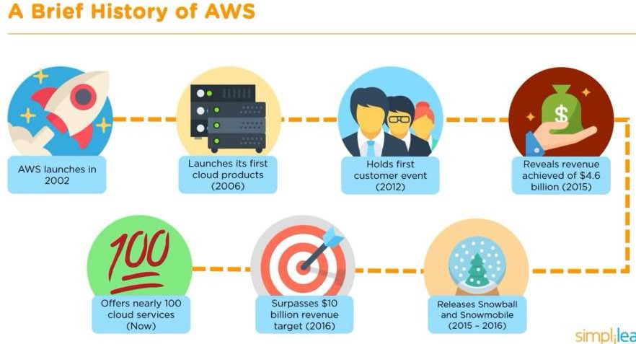

**Who Uses AWS?**

The number of organizations under the umbrella of AWS via IT environments is more like assessing globally successful organizations.

Using AWS, Adobe provides multi-terabyte working environments accessible by its customers by integrating the system using AWS Cloud. Adobe focuses on operating and organizing its software rather than putting effort to manage and deploy the infrastructure.

Airbnb, an online connected vacation rental marketplace for property owners and explorers to connect, sustains an enormous infrastructure in Amazon Web Services while using almost all accessible services.

Autodesk is developing software for the entertainment industries, engineering, and design. With the use of services such as Amazon S3 and Amazon RDS, Autodesk can increase its tools for learning machines rather than spending much time on infrastructure management.

America Online (AOL) uses AWS to close data centers, economize, and withdraw almost 14,000 co-located and in-house servers.

BitDefender is a firm that has internet security software whereby its software portfolio comprises anti-spyware and antivirus products. While using Amazon EC2 that is running various hundred cases handling data of about five terabytes. It also uses a feature known as Elastic Load Balancer to balance the load connection coming into those occurrences across accessibility zones, providing unified service delivery globally.

BMW uses AWS for its novel application for car connection, taking sensor data from BMW 7-series cars to enable drivers to assess map information dynamically.

With Amazon Web Services' use to distribute cloud-based services like office imaging products and mobile print, Canon's imaging products division tends to benefit from quicker deployment times, global accessibility, and lower cost.

Comcase uses AWS, the largest cable company globally and the United States' leading internet service provider for scalable hybrid infrastructure and flexibility.

Though more of the European Space Agency's work uses satellites, few of its data storage and computing infrastructure are developed on AWS.

The Guardian newspaper vastly uses AWS services to control an analytic dashboard primarily used by editors to view trending stories in recent times.

Amongst the world's leading business for news organizations is the Financial Times and uses Amazon Redshift for performing its analysis. Redshift can perform its analysis as fast as possible; some even thought it was malfunctioning. They were accustomed to the overnight running of queries. The Times, therefore, discovered that results were accurate, although much faster.

General Electric (GE) is presently migrating over 9,000 workloads and 300 disparate systems of ERP – to Amazon Web Services by reducing its data center footprint from 34 to four by 2021.

The list is endless, for example, McDonald's, Kellogg's, NASA, Howard Medical School, to mention but a few are profiting from AWS.

**Why is AWS so Successful?**

According to various reports from companies, principal aims for not only choosing AWS somewhat depending on it for vital measures of their IT infrastructure:

1. **Security and durability:** - Amazon Web Services encodes various data, presenting end-to-end confidentiality, including storage.
2. **Experience:** - Designers can depend on Amazon's reputable procedures. Including their techniques, tools including recommended top practices are made due to years of experience.
3. **Flexibility:** - There is excessive elasticity in Amazon Web Services, letting designers choose the OS language and database.
4. **Ease of Use:** - Amazon Web Services is easy to use. Designers can quickly organize and host apps, construct a novel, or even migrate existing apps.
5. **Scalability:** - Apps can easily be scaled up or down but, to an extent, depends on user desires.
6. **Cost savings:** - Organizations pay for the computing power, including usage of resources and storage, using no lasting commitments
7. **Security and durability:** - Amazon Web Services encodes various data, presenting end-to-end confidentiality, including storage.
8. **Experience:** - Designers can depend on Amazon's reputable procedures. Including their techniques, tools including recommended top practices are made due to years of experience.
9. **Flexibility:** - There is excessive elasticity in Amazon Web Services, letting designers choose the OS language and database.
10. **Ease of Use:** - Amazon Web Services is easy to use. Designers can quickly organize and host apps, construct a novel, or even migrate existing apps.
11. **Scalability:** - Apps can easily be scaled up or down but, to an extent, depends on user desires.
12. **Cost savings:** - Organizations pay for the computing power, including usage of resources and storage, using no lasting commitments.

**The Future of AWS**

As business and artificial intelligence, including IoT, evolve and indeed come into existence on their own, the necessity for data storage, cloud computing, and security would evolve to new levels. Additional services can be developed in the cloud, such as financial markets, healthcare, and other industries that will become more reliant on these technologies. Gratefully, AWS is out and remains to develop scalable and easy solutions for deploying and managing web apps in the cloud. It is evident that there's a bright future and that this cloud has a silver lining.

Suppose you're ready to be a part of the future of AWS. In that case, there's a certification course from Simplilearn that would prepare you to be an industry- ready, in-demand AWS solutions architect, with the privilege of firsthand experience with the management of AWS. You will study how IT architecture rules are redefined by cloud computing and how to scale and design Amazon Web Services cloud operations with Amazon's recommended best practices.

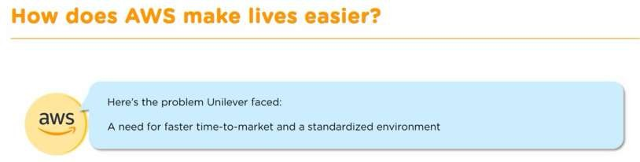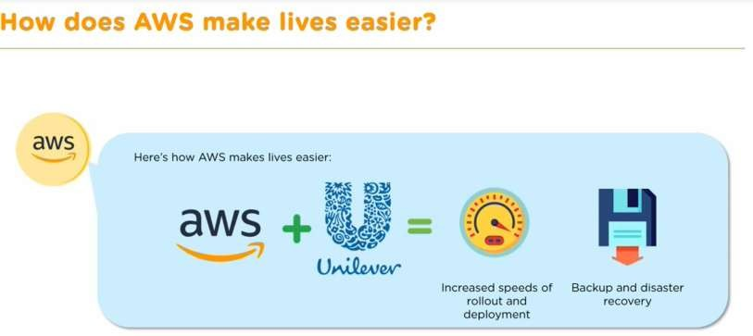

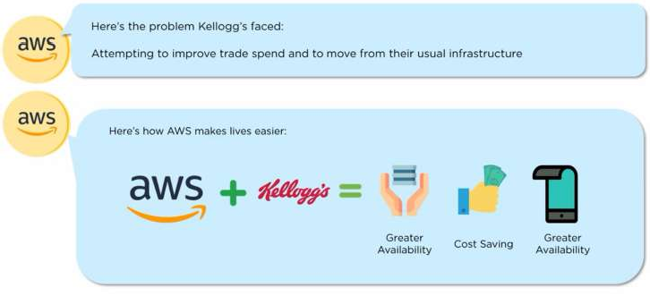

**Advantages of Amazon Web Services**

Unilever, a well-known organization in the world of consumer goods, would be used as an illustration.

Unilever had an issue: It required a quicker time-to-market and a consistent environment, and it's spread across 190 countries and uses digital marketing for its products. Its prevailing legacy in the local climate proved unworkable, incapable of catering to altering IT demands.

It then moved a portion of its business to Amazon Web Services, and ever since, rollouts have been smooth, provisioning apps have become dependable, and even infrastructure provisioning has increased.

The company can also do everything in scaling push-button and Amazon Web Service's backups that are secured to ensure that all company's data is accessible continuously and secured.

Unilever is currently developing with Amazon Web Services, kudos to characteristics like rapid rollouts deployment, capacity to produce current reports and securing backups.

**Why Use AWS?**

Below are the distinctive features that make Amazon's AWS a leader in the cloud market worldwide.

1. **Improved Security**

AWS creates a technological platform that is secured and long-lasting. To ensure that your data is secured and reliable, Amazon's data services and centers have different operational and physical security layers. Amazon Web Services also carry out audits regularly to make sure of the security of the infrastructure.

They're also best practices implemented in security and certification offers on ways to deploy AWS security features. There's the assurance of confidentiality, availability, and integrity of your data while providing end-to-end security and privacy.

In terms of cloud security provided by Amazon's AWS, they are earnest about it. Their recent addition to security services is called the Amazon Detective, making data investigations more efficient and even faster.

1. **Cost-Effectiveness**

A very distinguished advantage of AWS that is promising is the pay-as-you-go pricing model. It means that you pay only for a particular service you subscribed to, and it's only for that specific time you need it. It is a step ahead towards a smart-driven product for organizational development.

Amazon Web Services pricing is related to means through which you pay for utilities such as electricity and water. Therefore, you can pay only for consumed services and immediately discontinue their use, and termination fees or extra costs will not be included.

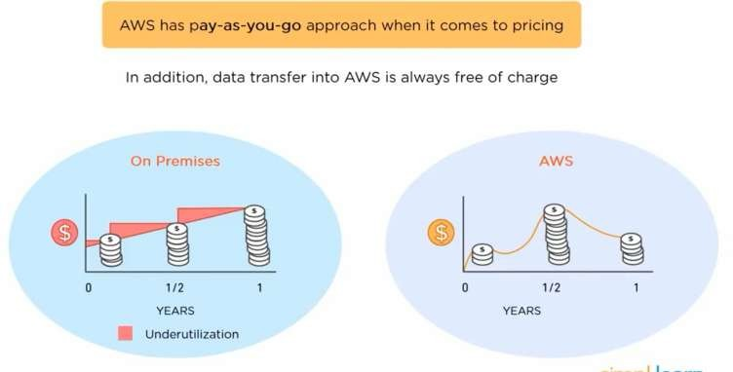

– Amazon AWS

There are other policies available that are valid for a particular Amazon Web Services. Here is some indication to enable you to comprehend which Amazon cloud computing cost plan will be paramount for your company.

***Save when you Reserve*** : The suggestion holds specific good services, including Amazon RDS and Amazon EC2. At this point, the real cost is rightly related to the discount accumulated, i.e., if you choose the pay, the total price up-front, then you'll get the extreme discount and vice-versa.

***Pay Less by Using More*** : For particular AWS services like S3 or data transfer OUT from EC2, the more the usage, the less you pay per Gigabyte (GB). These are volume-based discounts that enable you to profit in the long run.

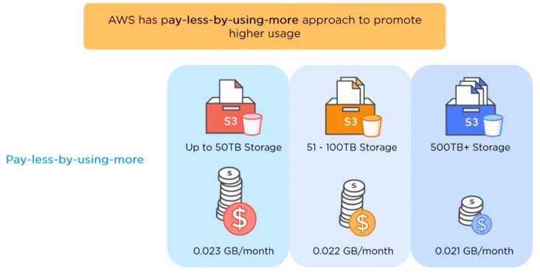

***AWS Free Tier*** : Upon creating a new account, over 60 AWS services can be accessed and freely offered. Nevertheless, these free offers are subdivided into three offers depending on the form of product an organization intends to use.

1. **Flexibility and Openness**

AWS is an agnostic-platform for operating languages and systems. You can choose the development platform or programming model that can be more favorable to your business.

Businesses are entitled to a potential environment that allows them to access services and software required by a specific application. Hence, no limitations or strict protocols while subscribing to Amazon cloud services that aid migration and enable the building of new solutions.

Furthermore, programming languages can be used, including databases, architectures, and programming languages you are accustomed to. In like manner, there won't be any requirement for your IT personnel to pick up a set of new skills, and the total time to market and productivity will considerably increase.

1. **Scalability and Elasticity**

Amazon Web Services allows you to experiment, innovate and iterate speedily via a huge cloud global infrastructure. Therefore, in leveraging scalability, Amazon Web Service can effortlessly manage the increase of workload by assigning the resources as a result of the demand, that also within minutes. New applications can as well be used instead of waiting for months for hardware while avoiding resource provisioning upfront for projects with lifetimes that are short and variable rates consumption.

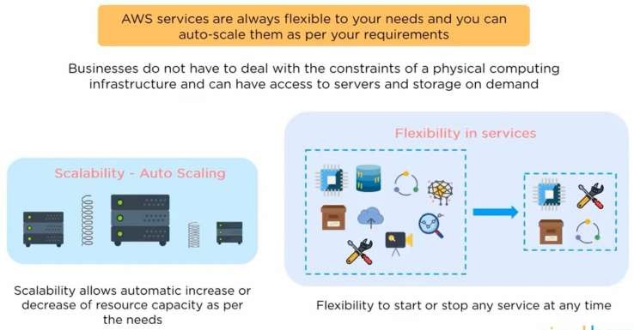

**Illustrating Scalability- Low demand vs. high demand**

AWS can allocate resources via API calls instead of buying hardware, maintaining, and setting it up to assign resources to apps.

**Illustrating elasticity- Low demand vs high demand**

Elastic load balancing and auto-scaling can automatically measure up Amazon cloud-based resources in the event of an unexpected rise in demand and scaling

them down whereby need is reduced. The Amazon Web Services cloud is also proved to be useful for recurrent jobs at consistent intervals, jobs that are difficult to accomplish, and short-term jobs.

**Services of AWS**

**Services provided by AWS**

All kinds of services in this “What is AWS” blog is characterized in the domain; the small number of domains that are generally used are:

* Compute
* Storage
* Database
* Migration
* Network and Content Delivery
* Management Tools
* Security & Identity Compliance
* Messaging

**The Computer Services**

The Compute domain comprises of services relating to computing jobs, it consists of the following services:

* EC2 (Elastic Compute Cloud)
* Lambda
* Elastic Beanstalk
* Amazon LightSail

**The Storage Services**

The Storage domain comprises of services relating to data storage, it consists of services as follows:

* S3 (Simple Storage Service)
* Elastic Block Store
* Amazon Glacier
* AWS Snowball

**The Database Services**

The Database domain is used for database related workloads, Its services consist of the following:

* Amazon Aurora
* Amazon RDS
* Amazon DynamoDB
* Amazon Redshift

**The Migration Services**

The Migration domain is used in transferring data to or from the AWS Infrastructure; it includes the following services:

* AWS Database Migration Service
* AWS SnowBall

**The Networking and Content Delivery Services**

The Content Delivery domain and Networking are used to isolate your content delivery and network infrastructure that is used in delivering content faster. The services consist of the following:

* Amazon Route 53
* AWS CloudFront

**The Management Tools**

The Management Tools domain comprises of services that are used in managing further services in AWS; the benefits include the following:

* AWS CloudWatch
* AWS CloudFomation
* AWS CloudTrail

**The Security & Identity, Compliance Services**

The Security and Identity, including the Compliance domain, comprises services used in managing authentication and providing security to your AWS resources. Its services comprise of the following:

* AWS IAM
* AWS KMS
* AWS Shield

**Messaging Services**

The Messaging domain includes services that are used in emailing, notifying, and queuing messages. Its domains comprise of the following:

* Amazon SQS
* Amazon SNS
* Amazon SES
* Amazon Pinpoint

Now that you have a rational idea of what AWS is and the services rendered in AWS let’s move ahead and immediately apply this information to form apps.

**Services that are commonly used and provided by Amazon Web Services**

Various services available on AWS cannot be overemphasized; they are security, tools development, migration, custom engagement, storage, and many more. Below are some of the services that are commonly used by Amazon Web Services:

1. **Amazon EC2** :- EC2 can be resettable due to the user's necessity, as long as a secured computing capacity is available in the cloud. For example, in situations whereby web traffic changes, this facility can increase its atmosphere, behind the scenes, to three occurrences when necessary and then contract to a single resource when weight reduces.

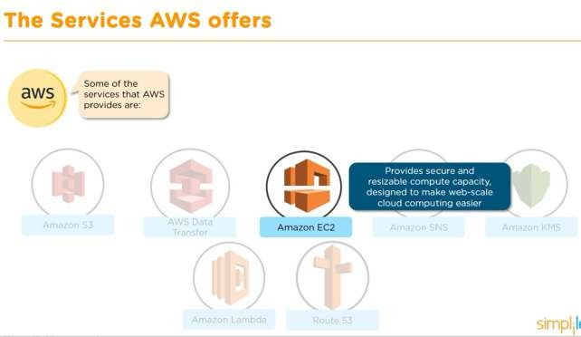

1. **Amazon Elastic Beanstalk: -** It consists of several programming languages; such service enables scale and organizes web apps. Just upload the required code, and the Elastic Beanstalk would automatically handle the setting from the capacity provision to load balancing and auto-scaling to app health checking.
2. **Amazon LightSail:** - Easy to present and manage, Amazon Lightsail is essentially a confidential server and contains all required to launch a project without delay on a computer-generated machine, such as tools for transferring data, SSD-based storage, static IP, and DNS management.
3. **Amazon Lambda:** - It enables organizations for code running with no use for server management and provisioning. It automatically scales little requests for a day to so many for a second. Organizations pay for the time used for computing and no charges while code isn't running.

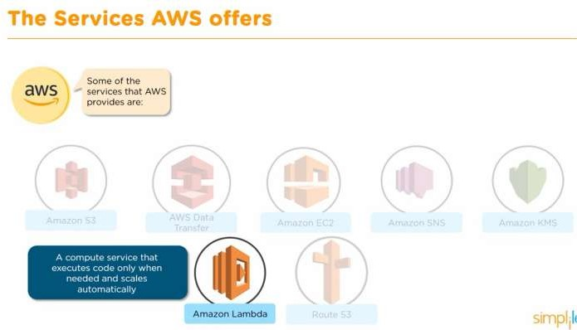

**Amazon Web Services Storage Services**

With the quantity of data organizations collect, storing the data seems to be high in demand. AWS, therefore, helps bring numerous solutions listed below:

* **Amazon S3** – With S3, data can be stored and retrieved from anywhere, including IoT sensors, mobile apps, websites, and others. There's flexibility in data management, security, and durability for internet storage.
* **Amazon Glacier** – It's a service for cloud storage meant for storing data for future use, including long-term backups, highly secure options, and low-cost Glacier.
* **Amazon Elastic Block Store (EBS)** - EBS offers block store volumes for cases of EC2. It is a dependable storage volume attached to whichever running instance in a similar accessibility zone.
* **Amazon Elastic File System (EFS):** - EFS can be used with the Amazon Web Services Cloud resources and services. It's scalable and straightforward; it's flexible storing of files for on-premise resources. Containing an intuitive interface allows users to build and file configuring systems without troubling the app growth and automatic shrinking when files are being added or even removed.

**Amazon Web Services Databases**

Amazon Web Services offers databases in dual primary flavors:

* 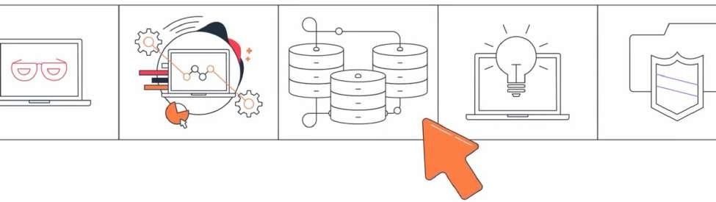**Amazon RDS** - Easing the process of setting up, operating, and scaling a relational database in the cloud, Amazon RDS provides cost-efficient and resizable capacity while automating time-consuming administrative tasks such as database hardware setup, repairing, and backups. The enhanced service is for memory performance and output/input processes. Amazon RDS gives you the freedom to use your relational database of choice including the most popular open source and commercial agents and amazon relational database built for the cloud, Amazon Aurora, which offers the performance and availability of traditional commercial databases and fraction of the cost. RDS enables you to scale across a global footprint of data with enterprise high availability and disasater recovery no matter the size, it automates many previous cumbersome task, automatic failover, backups at point in time are restored, disaster recover, access management, encryption, secure networking, monitoring and performance optimization. All these and more can be enabled with a few clicks or API codes. Even, highly regulated industries can leverage RDS which means a broad range of compliance certifications.
* **Amazon Redshift** is a data warehousing service allowing users to examine data with SQL and other intelligence business instruments. It can be used in running multifaceted queries compared to terabytes of organized data and obtain results in seconds.



**HOW TO SIGN UP ON AWS**

**Step 1:** Launch into aws.amazon.com and tap on ‘Create an AWS Account.’ **Step 2:** Tap on the option that states ‘I am a new customer,’ and input your email address, and at last tap on Sign In.

**Step 3:** The next page is to fill in all the applicable information and tap on Create Account.

**Step 4:** The next page is to enter your details and tap on ‘Create Account.’

**Step 5:** Then, you’ll be asked to input the details of your credit or debit card on this page; immediately you’re done with that, continue by tapping on ‘continue.’ **Step 6:** The next Stage would be verifying your phone number, input the details, and tap on ‘Call me Now.’

**Step 7:** You will then get a call from AWS, and you’ll be requested to input a pin, following by choosing your plan for AWS, but before that, tap on ‘Next.’ **Step 8:** You will now choose a plan suitable for you; we’ll use a basic plan because this account would be done for personal use.

**Step 9:** Congratulations! Your AWS Account has been created and ready for use! Go sign in and play!

Since you now have an AWS account at your beck and call, why don’t we do some hands-on? What do you think?

Let’s launch a PHP website on EC2 while backing it up with an RDS MySQL database. You may not be used to such services; it’s not a big deal; allow me to clarify you:

Elastic Compute Cloud is a compute service accessible by AWS that offers resizable compute ability in the cloud.

**IMPLEMENTATION**

**Architecture Statement:** Deploy a three-tier architecture on AWS

**Services used:**

* **Virtual Private Cloud (VPC)**
* Amazon EC2 (Elastic Compute Cloud)
* Amazon RDS
* [Elastic Load Balancing](http://aws.amazon.com/elasticloadbalancing/)

**ARCHITECTURE:**

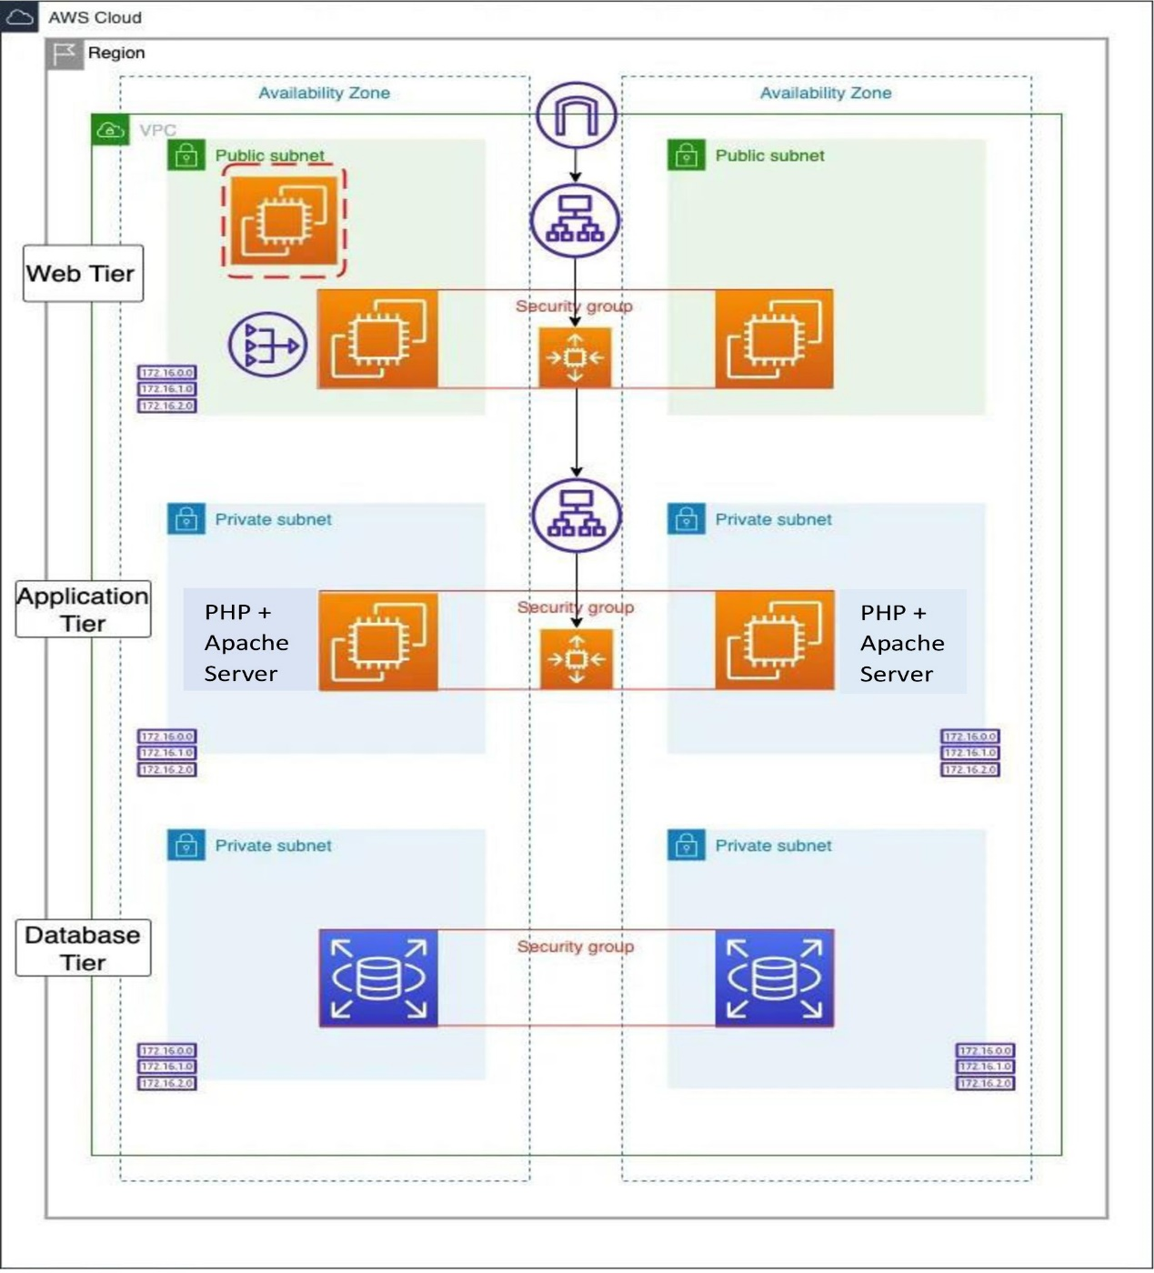

**HOW I DEPLOYED A THREE-TIER WEB APPLICATION ON AWS:**

**A Three-tier architecture** includes a presentation tier (public layer) which is exposed to the internet, Logic tier (application layer) which is private, and a data tier (database layer) which is also private. The idea is that the public layer should act as a shield to the private layers. Anything in the public layer is publicly accessible but resources in the private layers can only be accessed from inside the network.

With Three-tier architecture, we are providing the following solutions:

1. Scalability
2. High availability
3. Fault-tolerant
4. Security
5. Improved performance

**- So, in this project, we deployed a Three-Tier web application on AWS.**

Below is the requirement for this project:

1. AWS Account (free tier)
2. Putty or any of your favourite SSH client

**STEP 1**: **SIGN IN TO YOUR AWS MANAGEMENT CONSOLE**

**STEP 2:** **CREATE A VPC**

**A Virtual Private Cloud (VPC)** is a secure, isolated private cloud hosted within a public cloud (AWS). It can help you manage your AWS resources in a secured and scalable manner. This is what we want to achieve below:

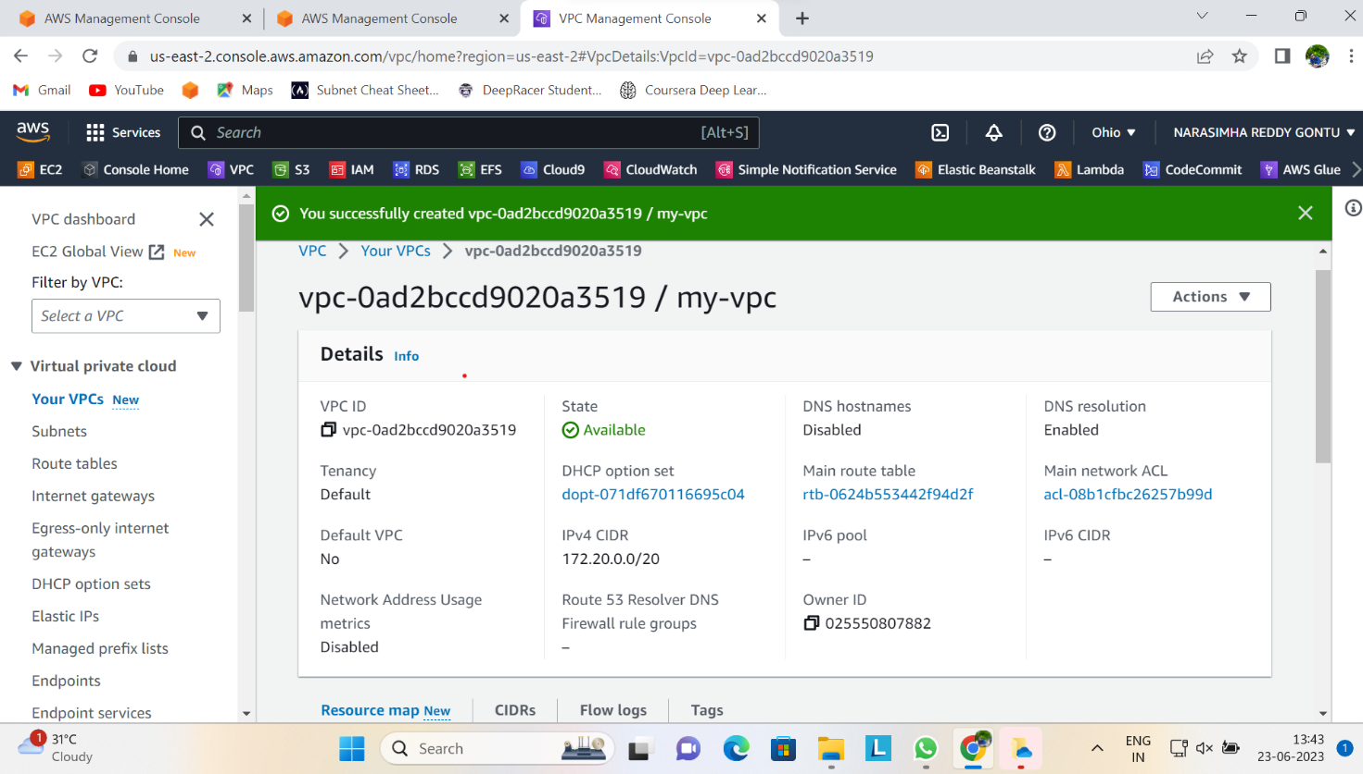

**How to create the VPC**

Navigate to the VPC section and click on Create VPC option. Give the name of your VPC and CIDR block you want to use. Leave every other thing as default and click on Create.

**STEP 3. CREATE SUBNETS**

You have to create 9 subnets and below are the ways I classified them

* 3 Public subnets in 3 different availability zones
* 3 private subnets in 3 different availability zones
* Another 3 subnets for database in different availability zones

Remember to use a good naming convention in other not to mistake one for another. Kindly see how I created mine below.

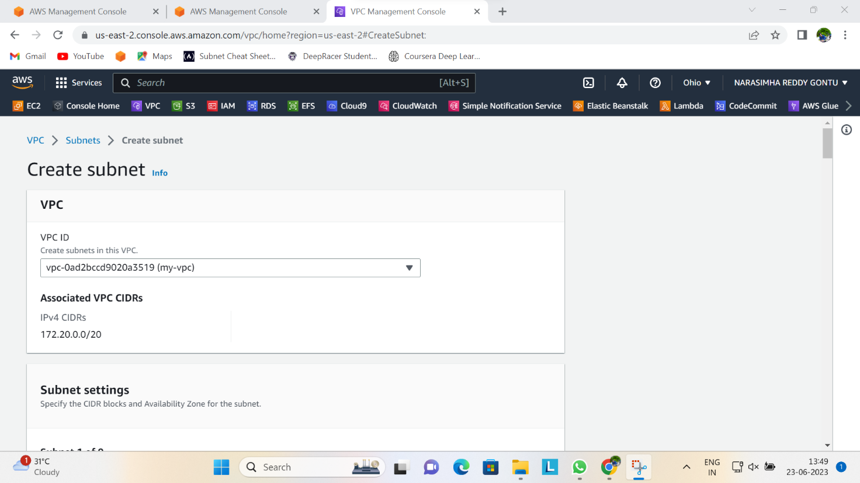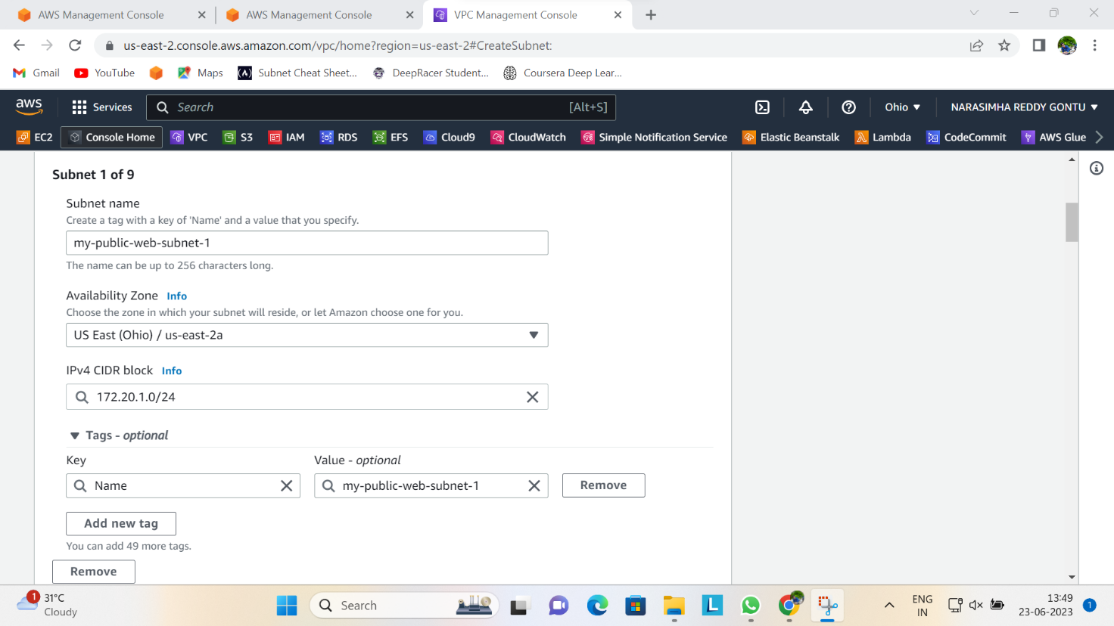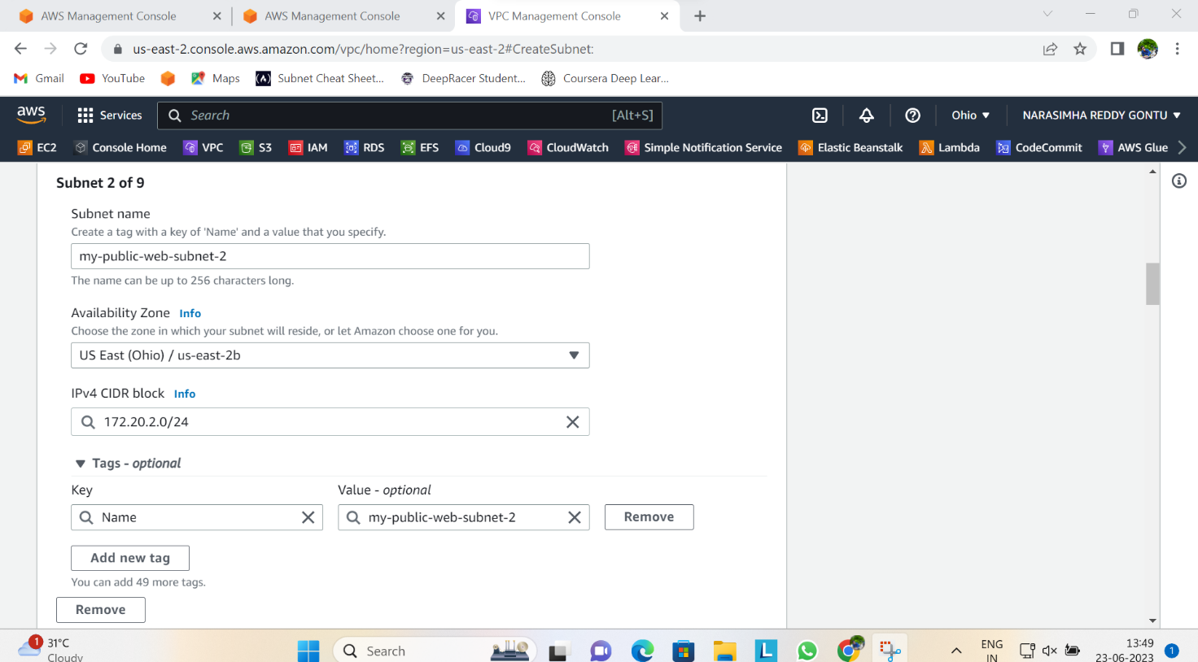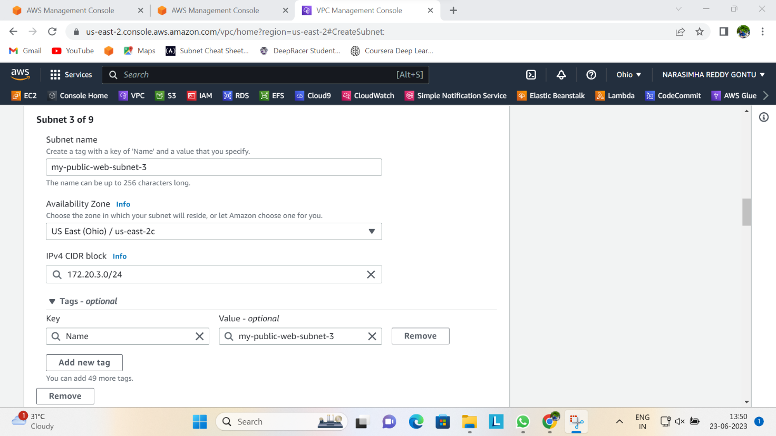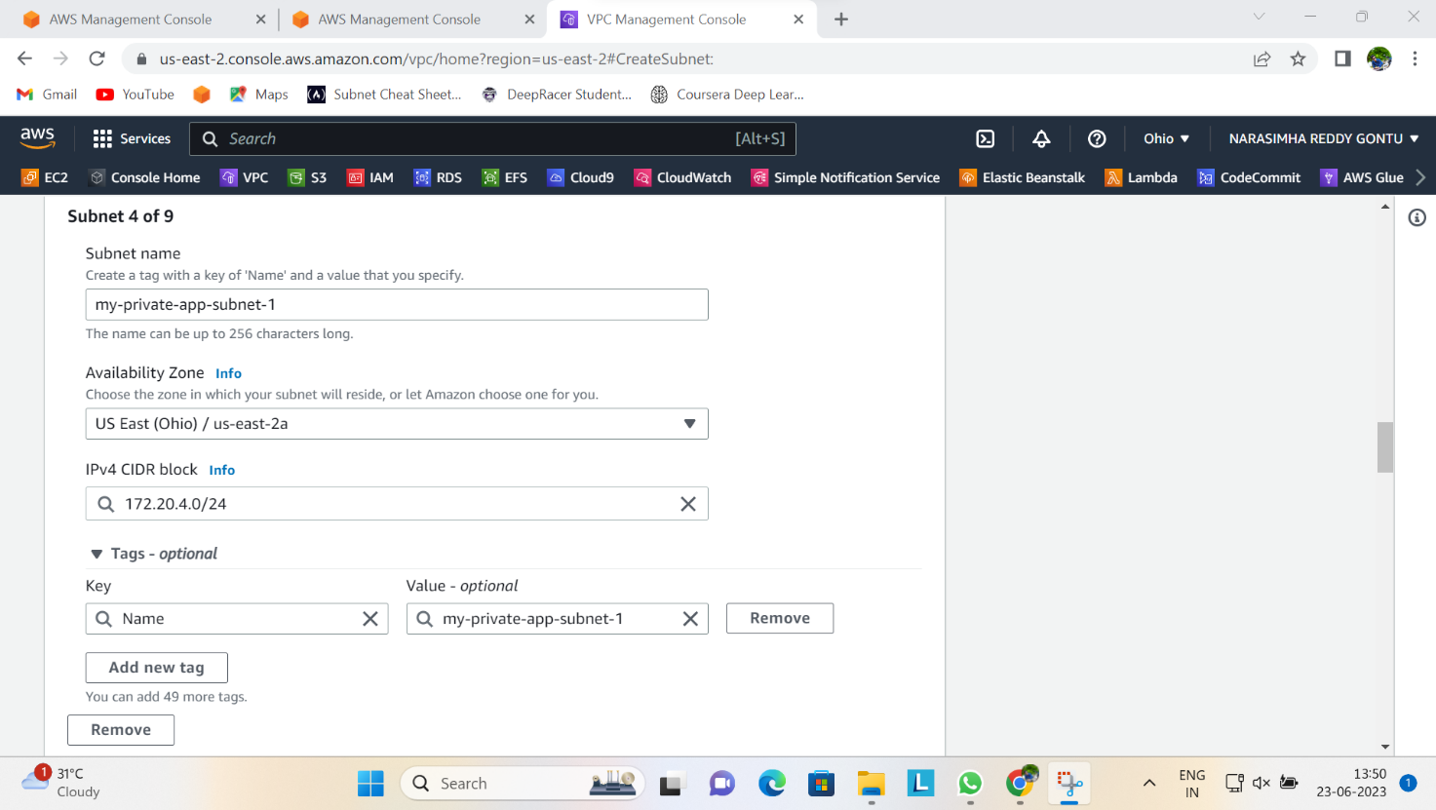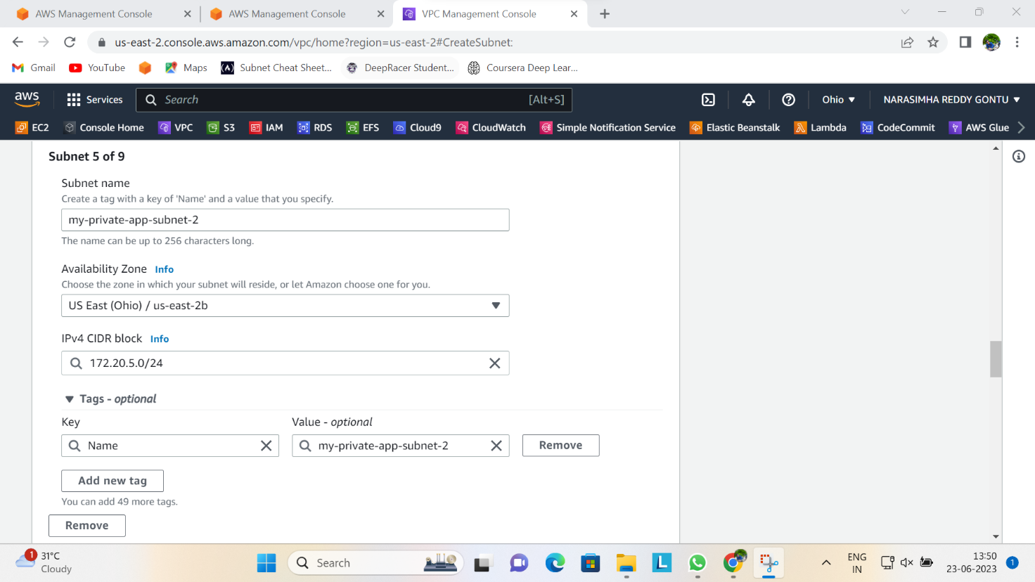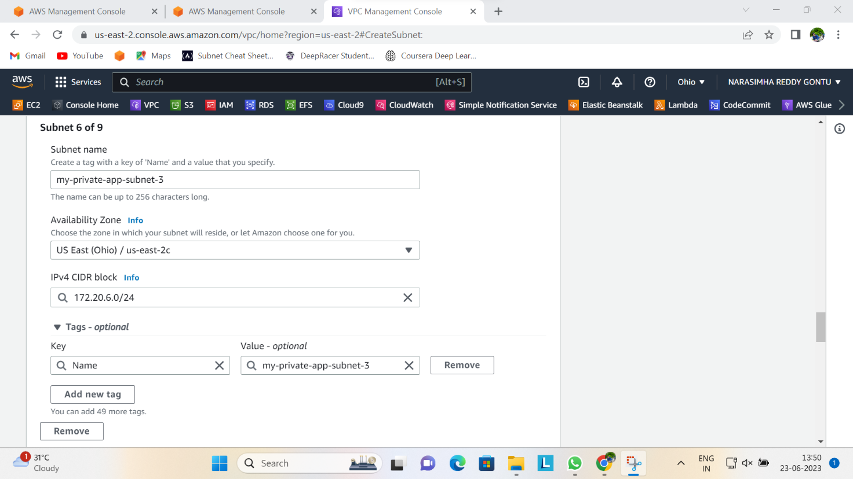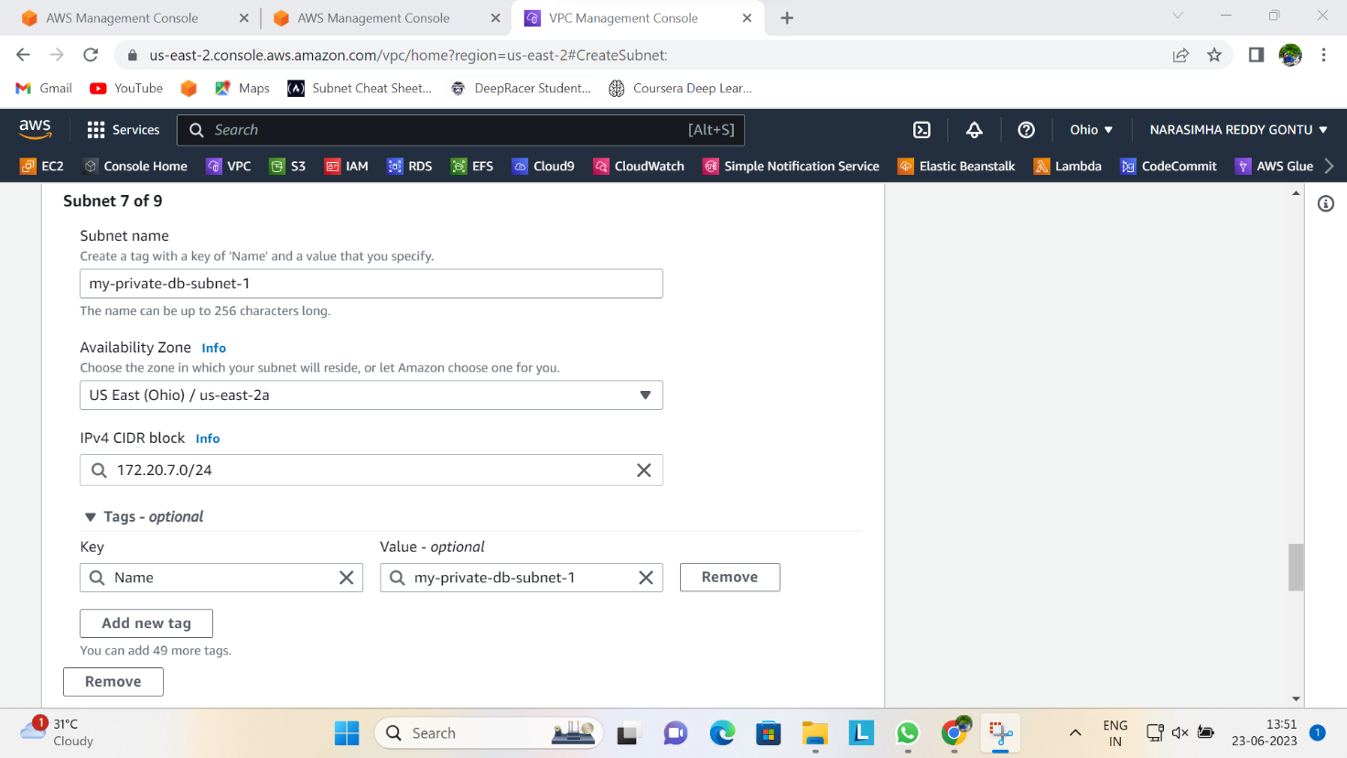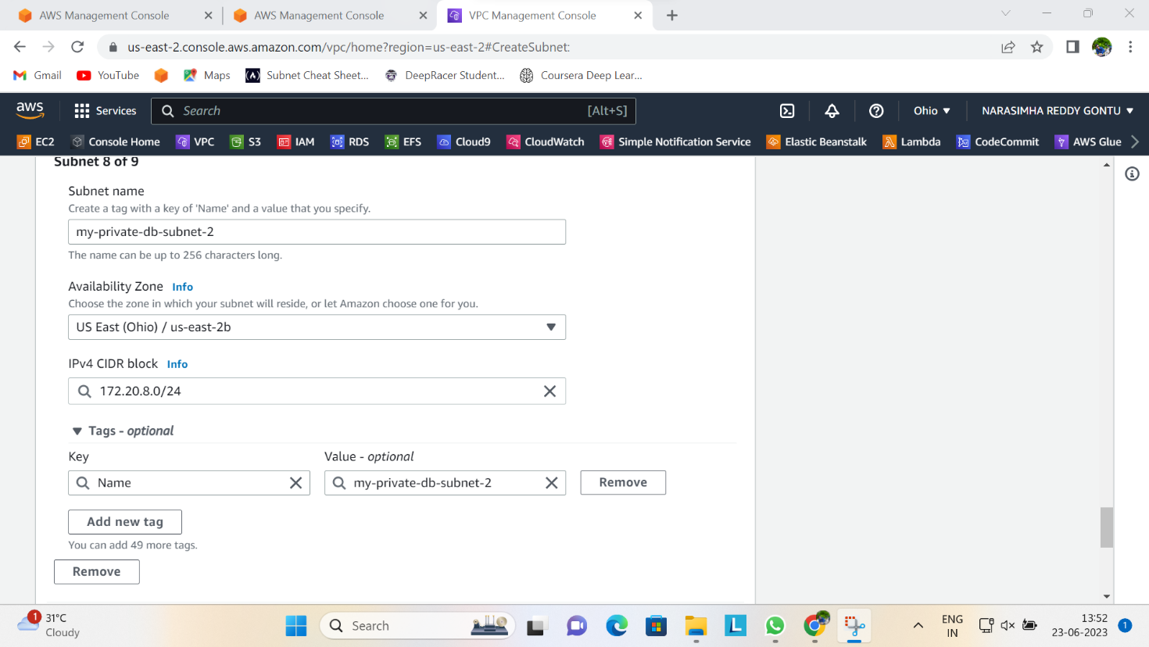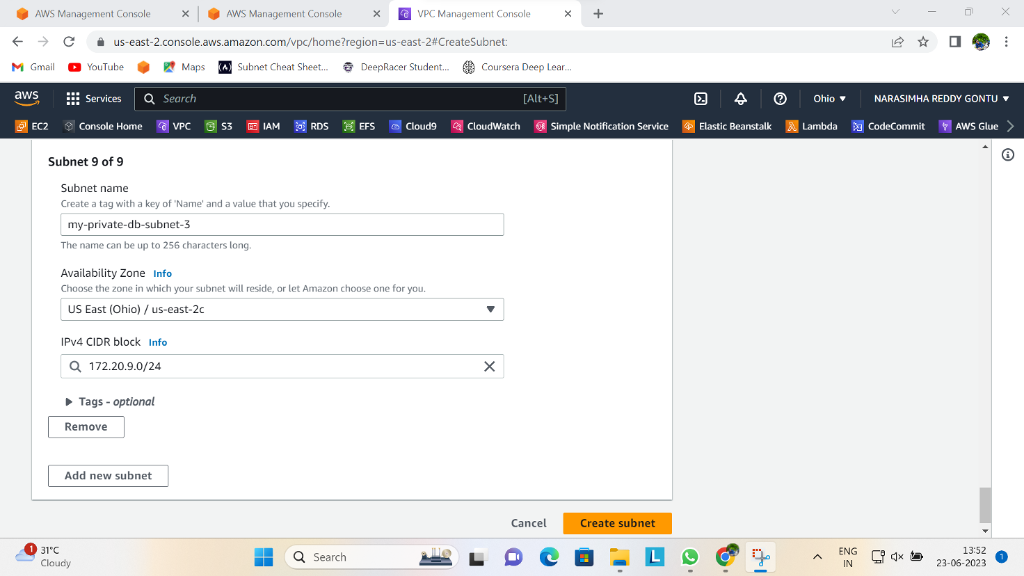

**STEP 4: CREATE A ROUTE TABLE**

When you create a VPC, it creates a default route table, however, you need to create yours. So you have to create 3 route tables for this project

**Create 3 Route tables**

* The first should be a public route table (Web layer)
* The second should be private (Application layer)
* The third should be for your database (Database layer)

Ensure you select the VPC you have created when creating each of them. The image below displays the creation of the public route table.

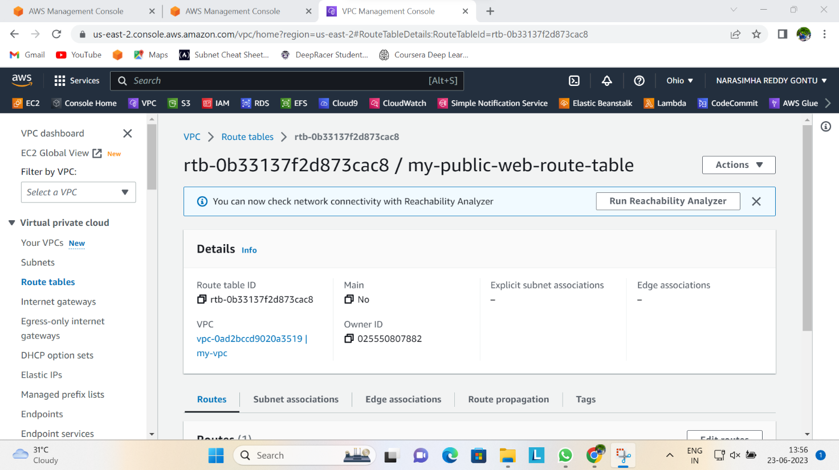

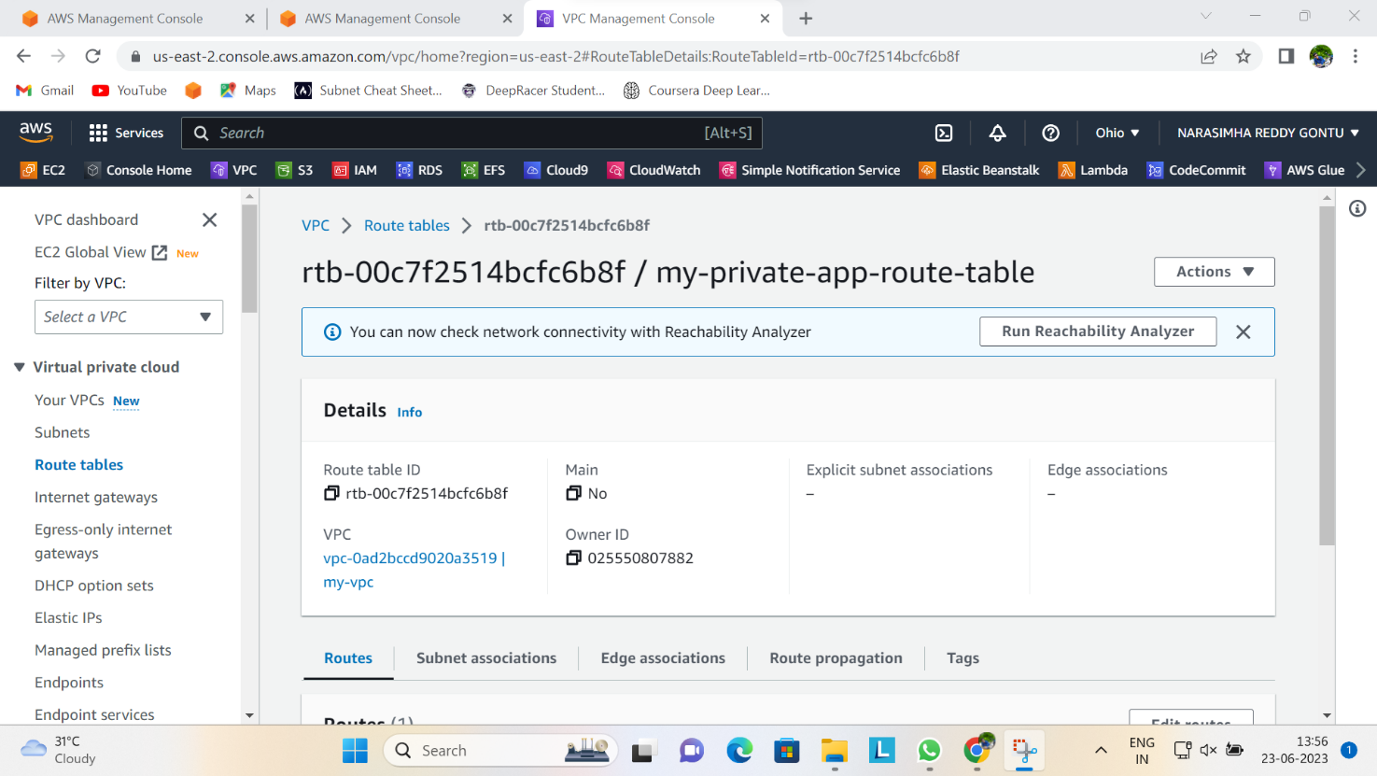

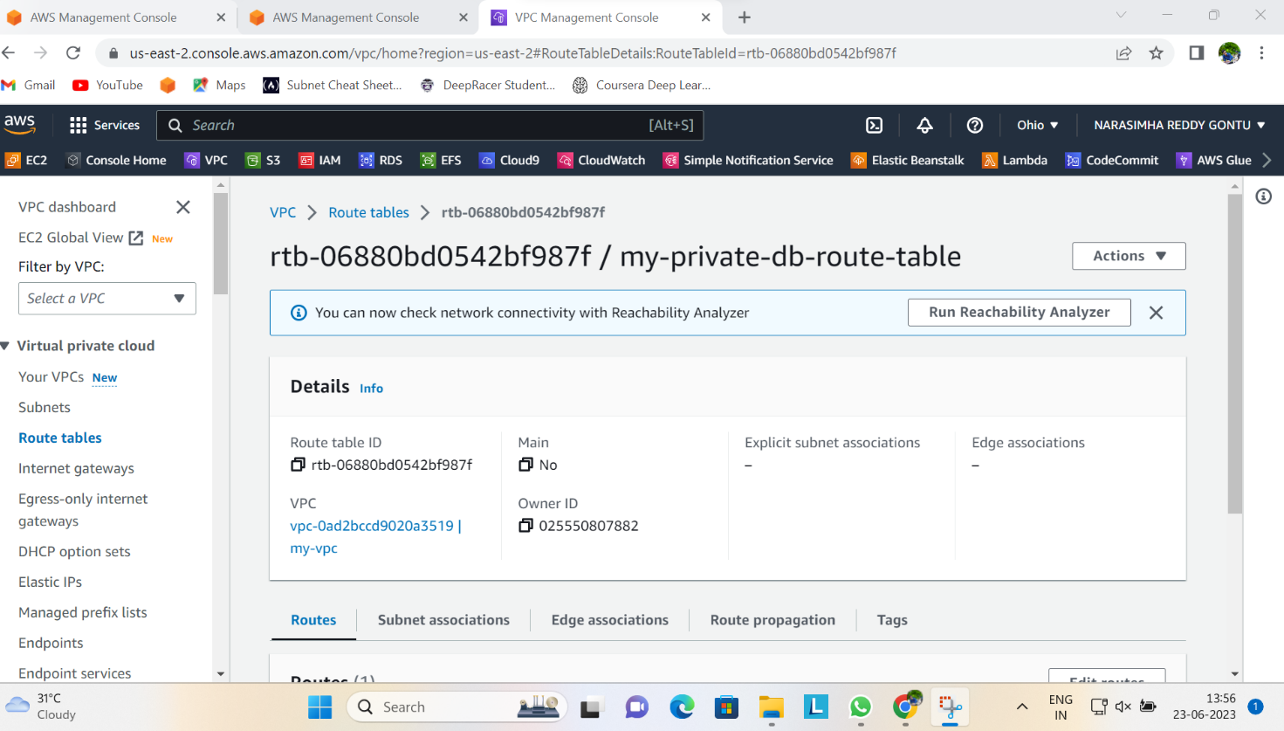

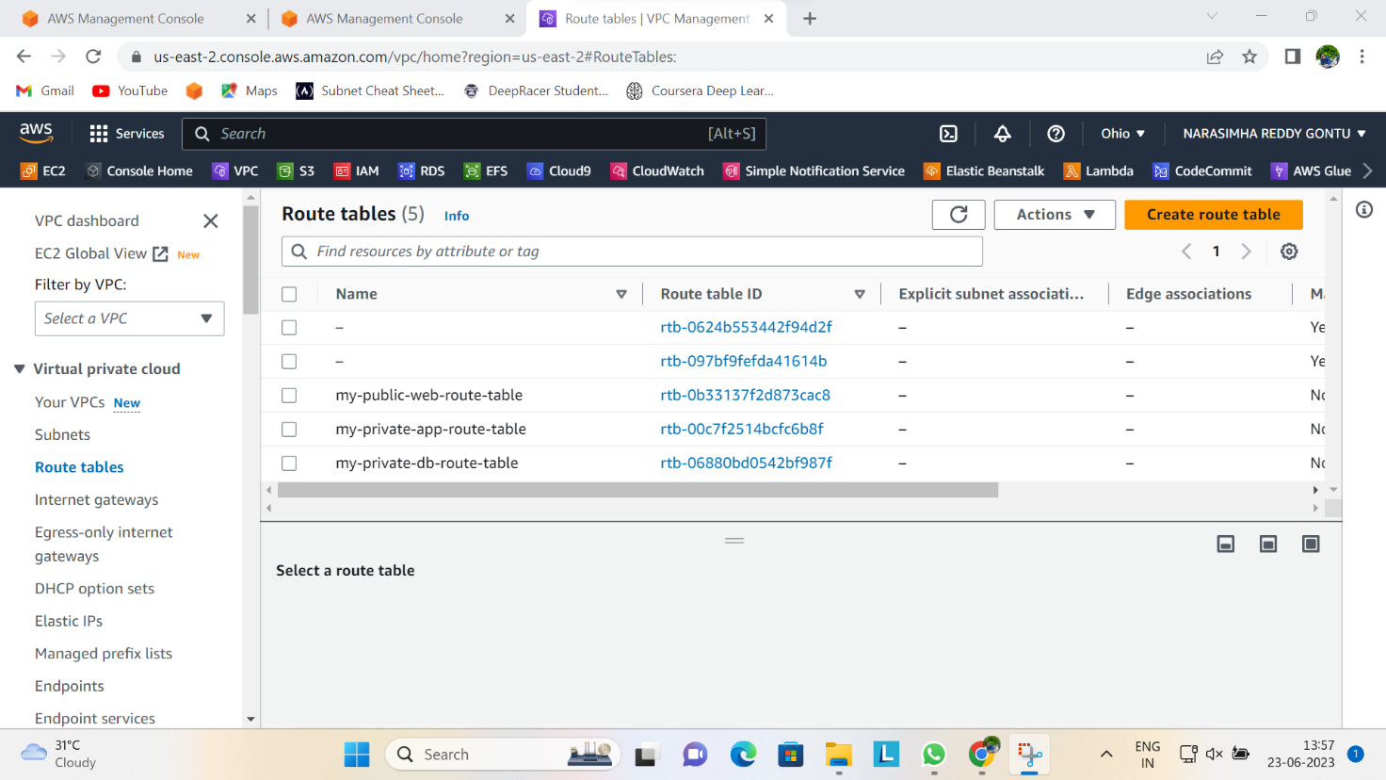

**STEP 5: ROUTE TABLE ASSOCIATION**

It is not enough to create these route table, you need to associate each route table with appropriate subnets. Select each route table and click on **subnet associations** beneath the table and then click **Edit subnet association**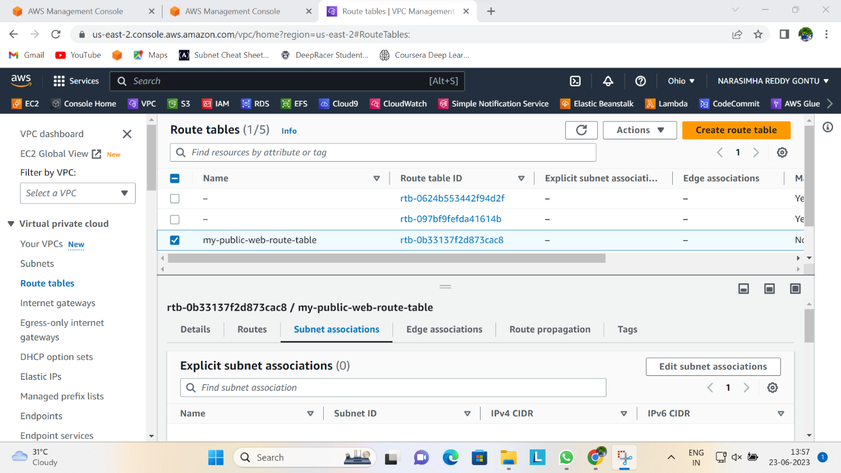

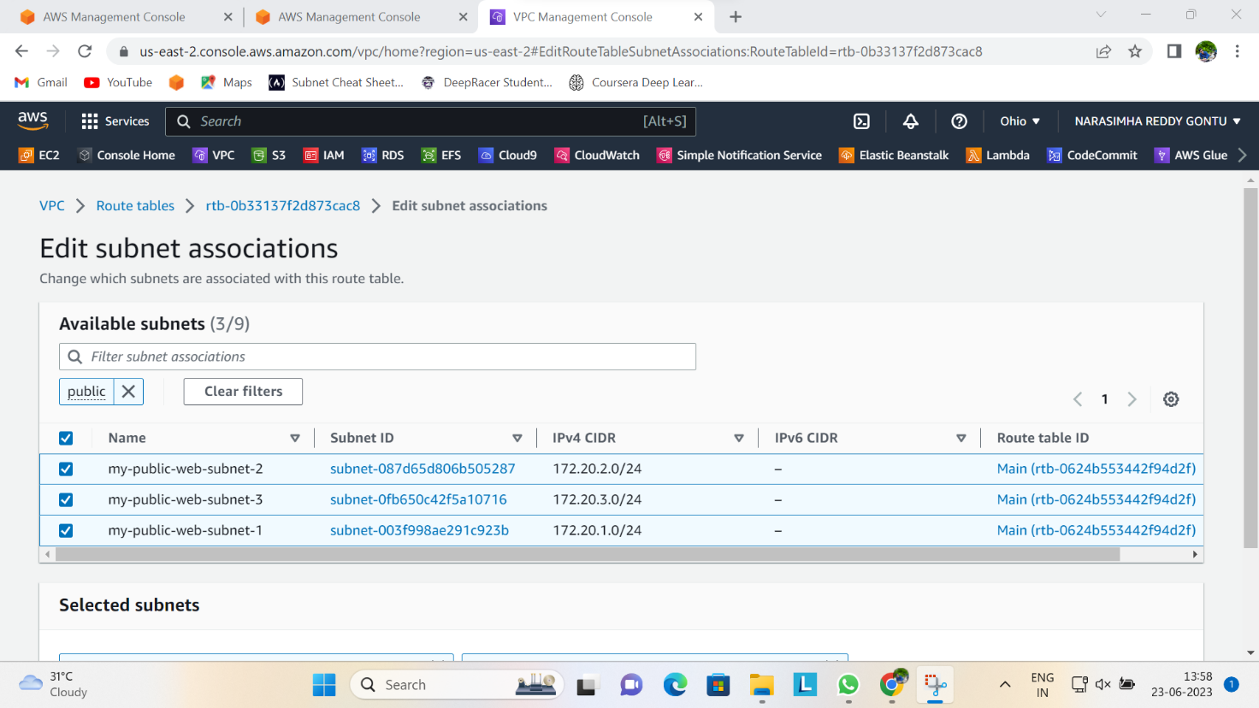

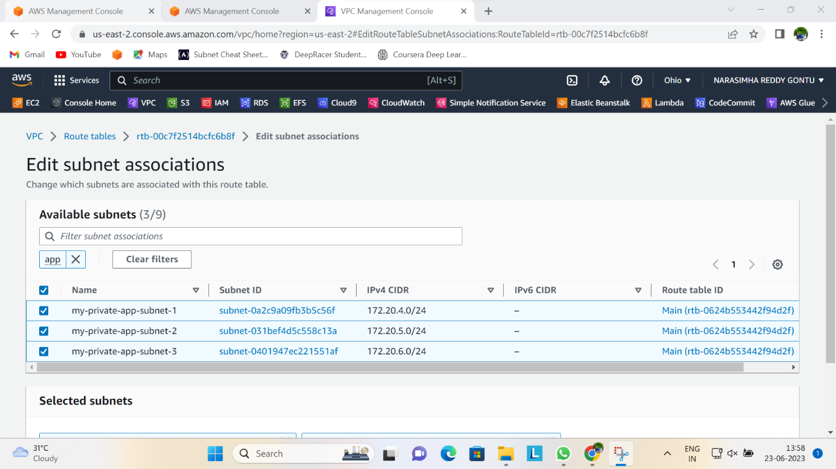

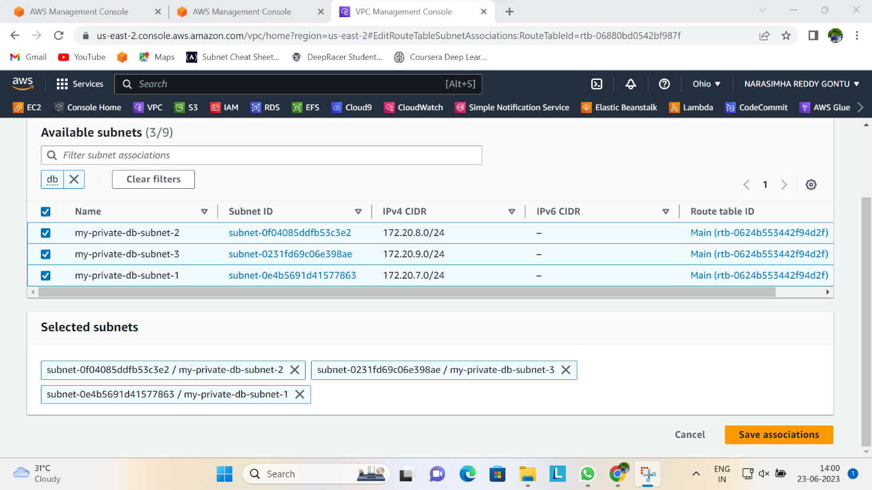

As you can see from the image above I selected all the public subnets, associated them with my public route table, and clicked on save association.

Secondly, selected the private App route table and following the procedure in the first association, associate it with the 3 private app subnets.

Also, do the same for the database route table and associate it with the private subnets you created for your database.

**STEP 6: CREATE AN INTERNET GATEWAY**

Since you have created route tables, you need to create an internet gateway in order to establish connectivity. Beneath the route table pane, click on internet gateway and **create internet gateway**

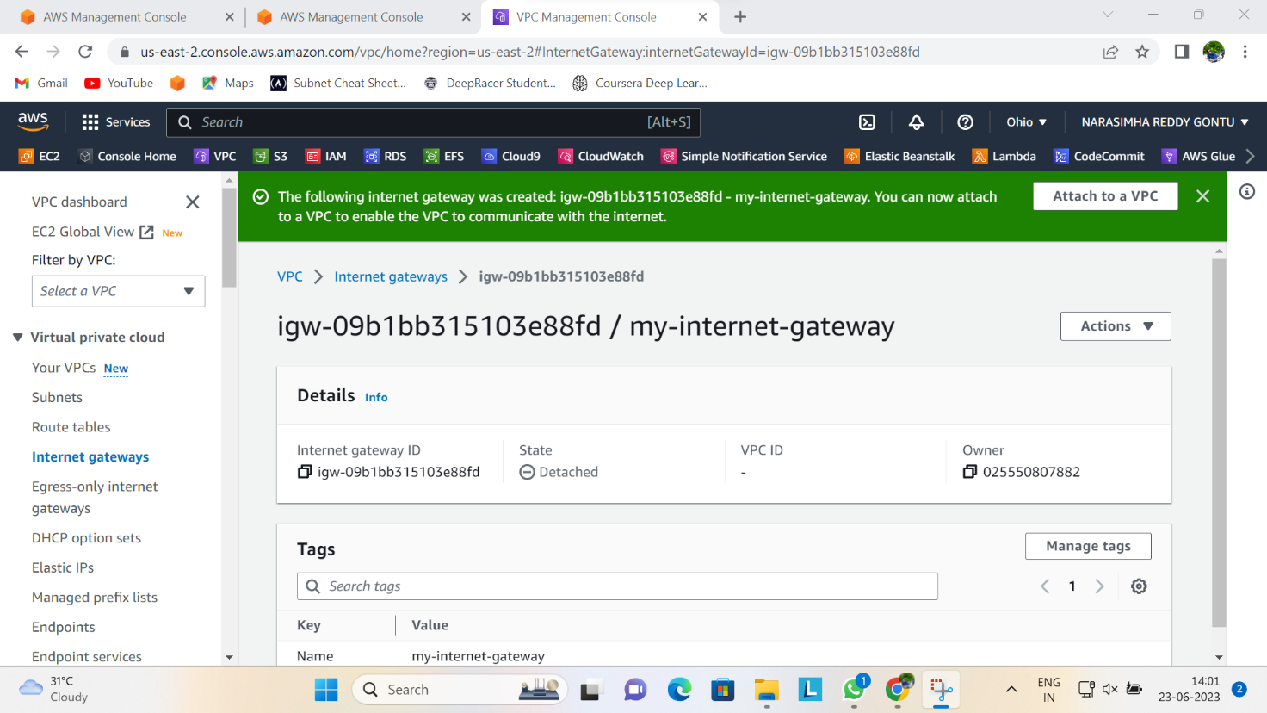

Once created, select the internet gateway, at the action button at the top, click on **attach to VPC**

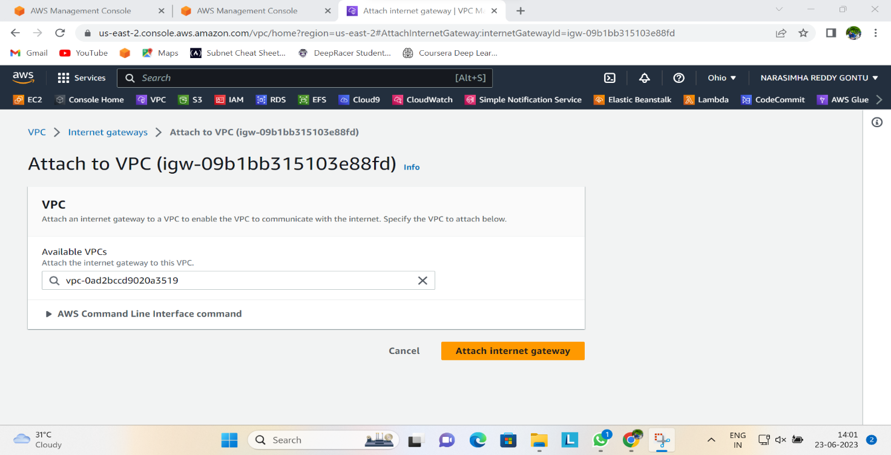

**STEP 7: CREATE A NAT GATEWAY**

For best practices, you need to create multiple NAT gateways to ensure redundancy, but in this project, you can create only one and it should in a public subnet.Navigate to NAT gateway section and click on **create NAT gateway**

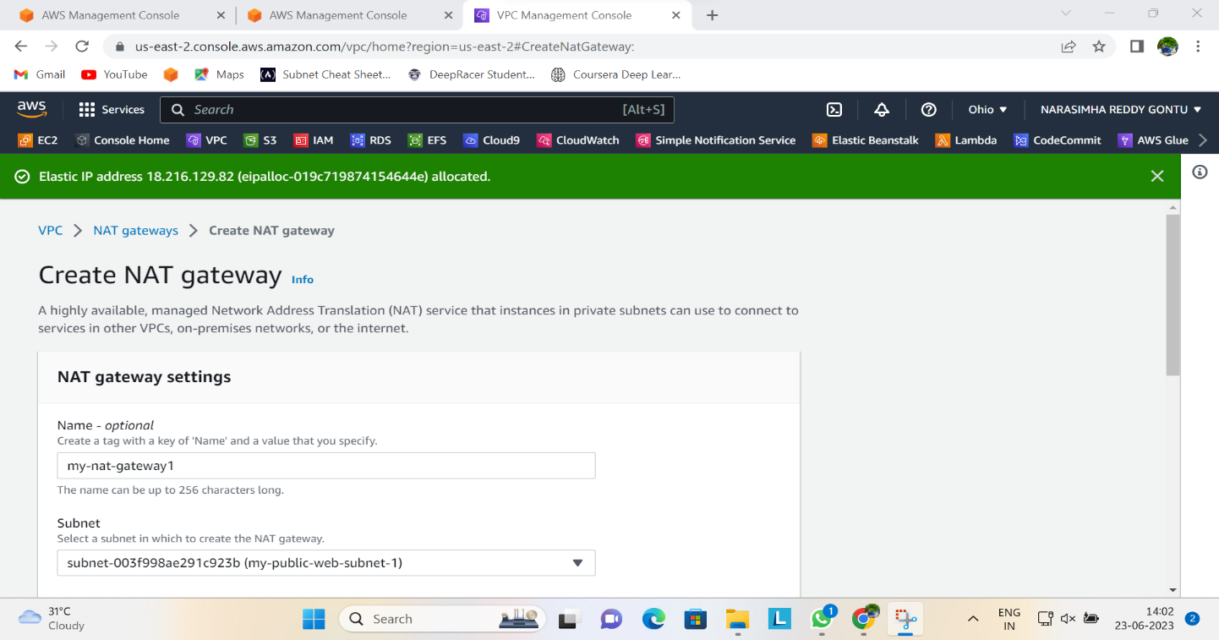Click on **Allocate elastic IP** to allocate one to your NAT Gateway and then click on **Create NAT Gateway.**

**STEP 8: ESTABLISH INTERNET CONNECTIVITY VIA THE INTERNET GATEWAY.**

This requires you need to select your public route table and edit the route. In the image below I selected my public route table and clicked on the route option just beneath the table and then clicked on edit routes. Please do same and then click on add route, select the destination as 0.0.0.0/0 and under the target, select internet gateway you created and save it.

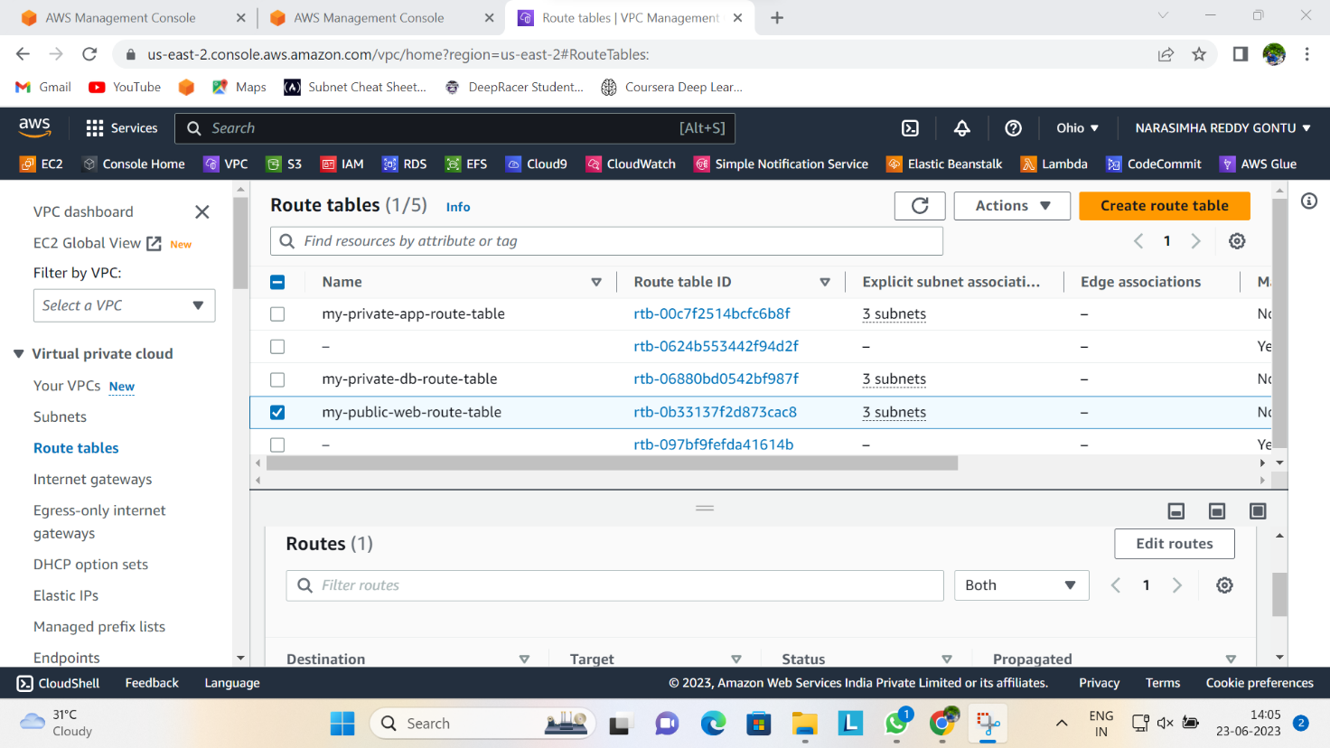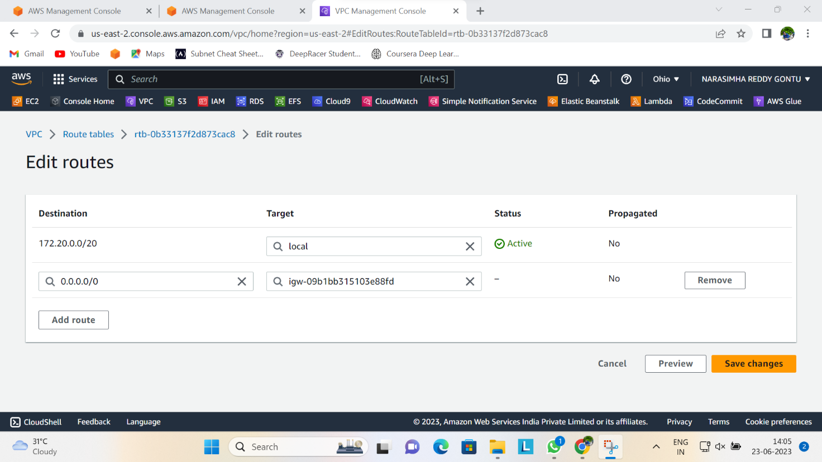

**STEP 9. ADD NAT GATEWAY TO THE PRIVATE APP ROUTE TABLE.**

This is actually similar to the previous step above. So here you will be associating the private app route table with NAT gateway. Select the route table and click on route option just beneath the table and then clicked on edit routes. then click on add route, select the destination as 0.0.0.0/0 and under the target, select NAT gateway you created and save it.

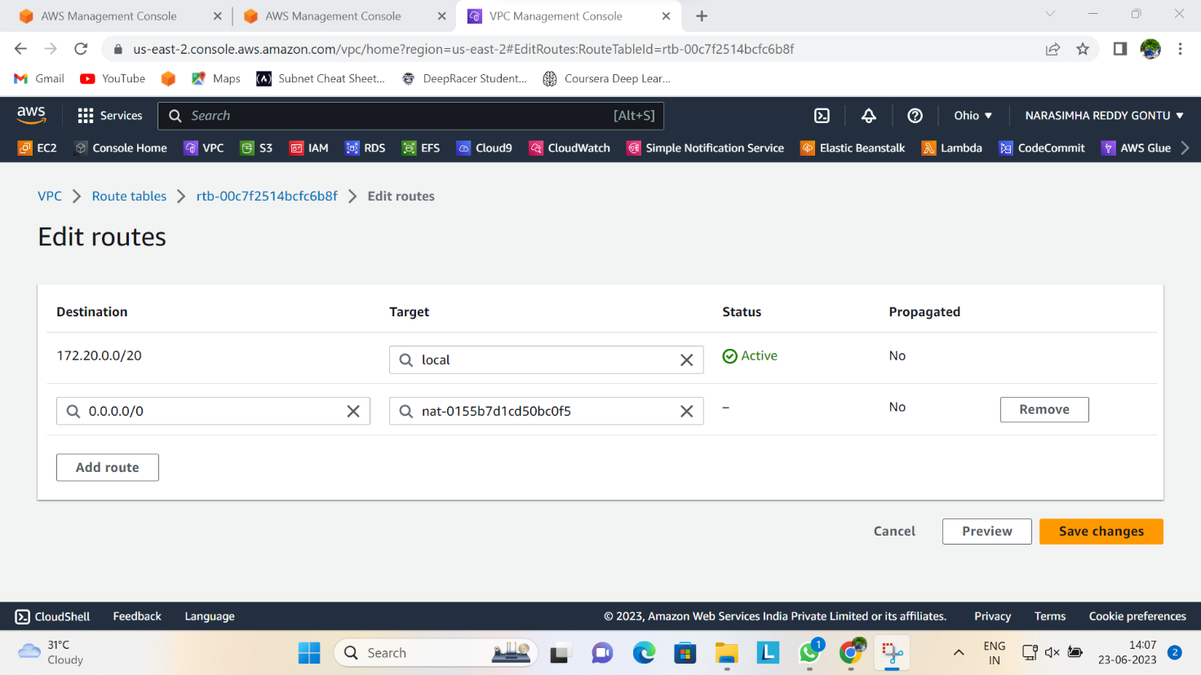

**STEP 10. ADD NAT GATEWAY TO ROUTE TABLE OF YOUR DATABASE**

Kindly refer to 9th step

**STEP 11. DEPLOY APPLICATION COMPONENTS**

This is where you need to start deploying your instances.

First, start by creating an EC2 instance for your web server.

Choose Amazon linux, t2.micro as instance type, select the VPC you created under network settings and select public subnet 1 in first availability zone. Enable auto assign public IP address. Next is to select your key pair if you have one already, but if you don't have one, click on create key pair and attach it. Create a security group with default SSH port 22. My EC2 creation image is shown below:

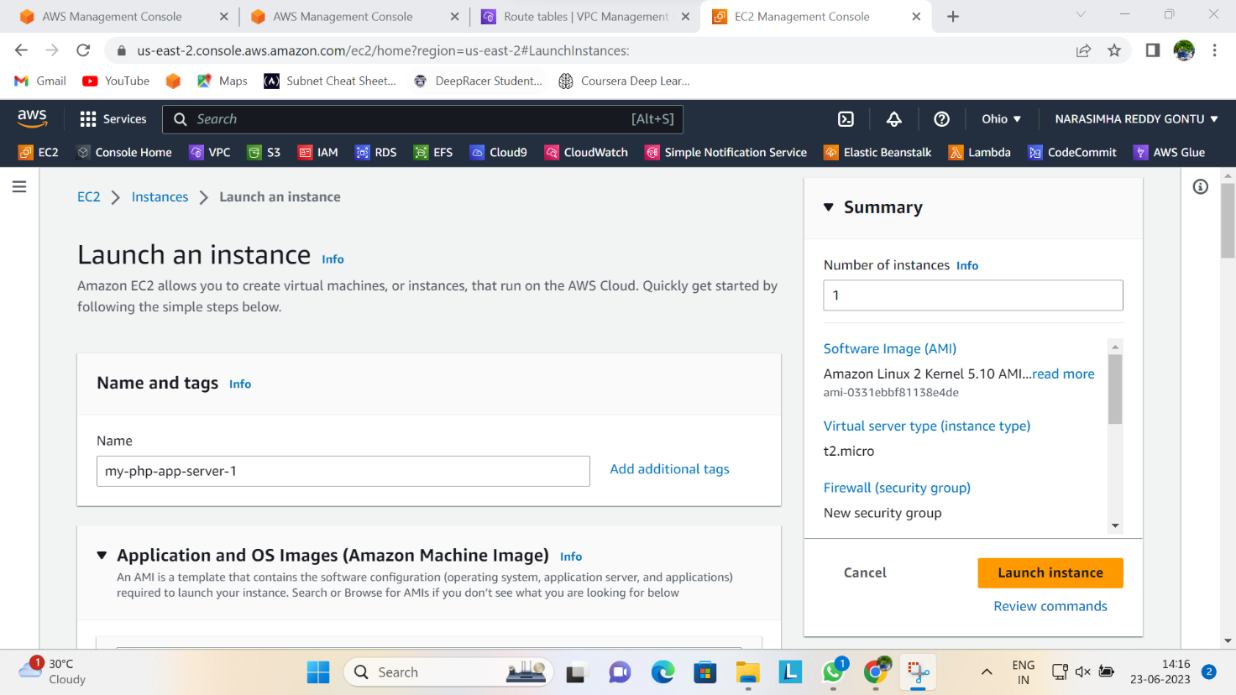

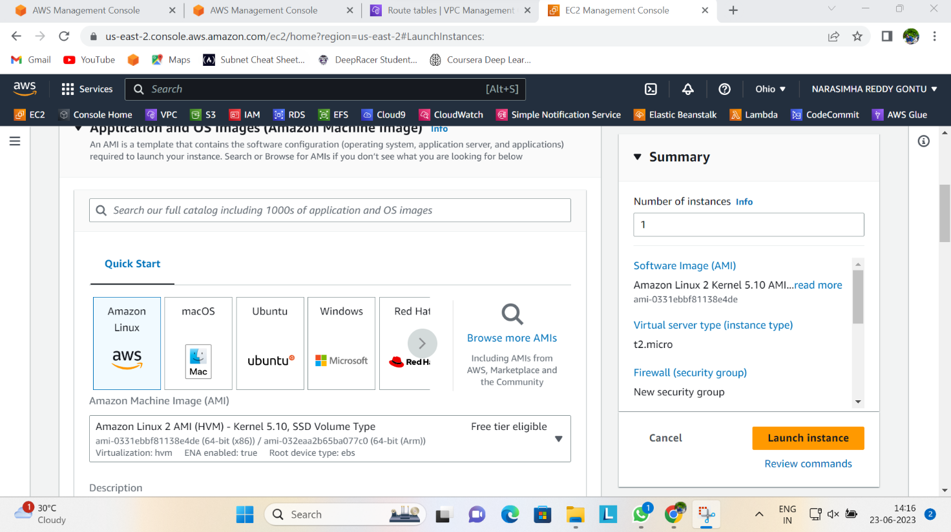

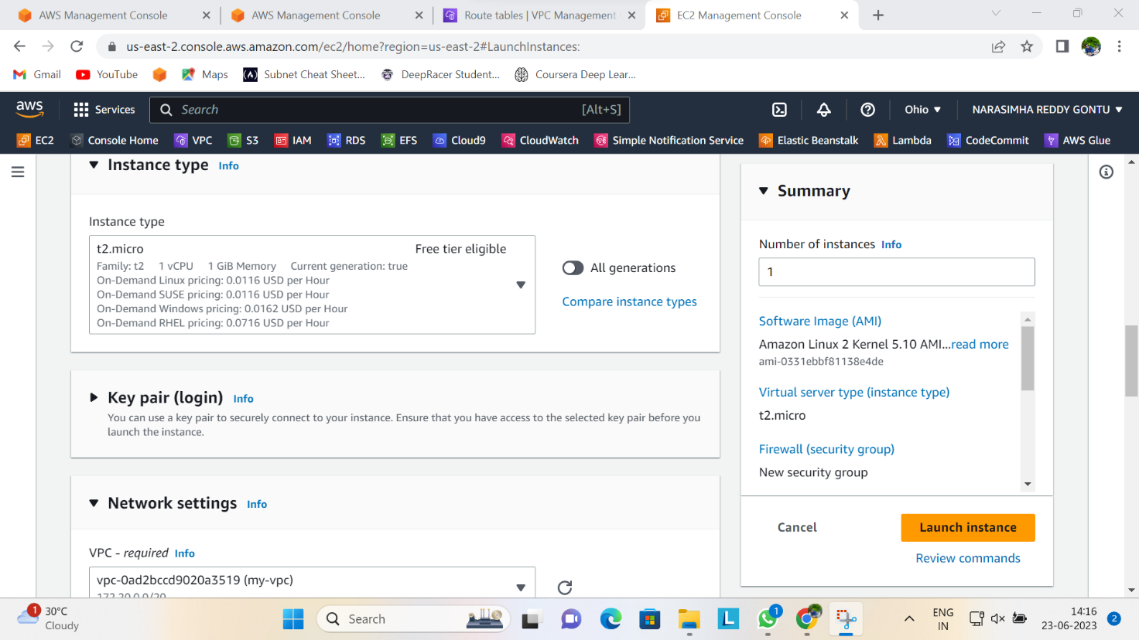

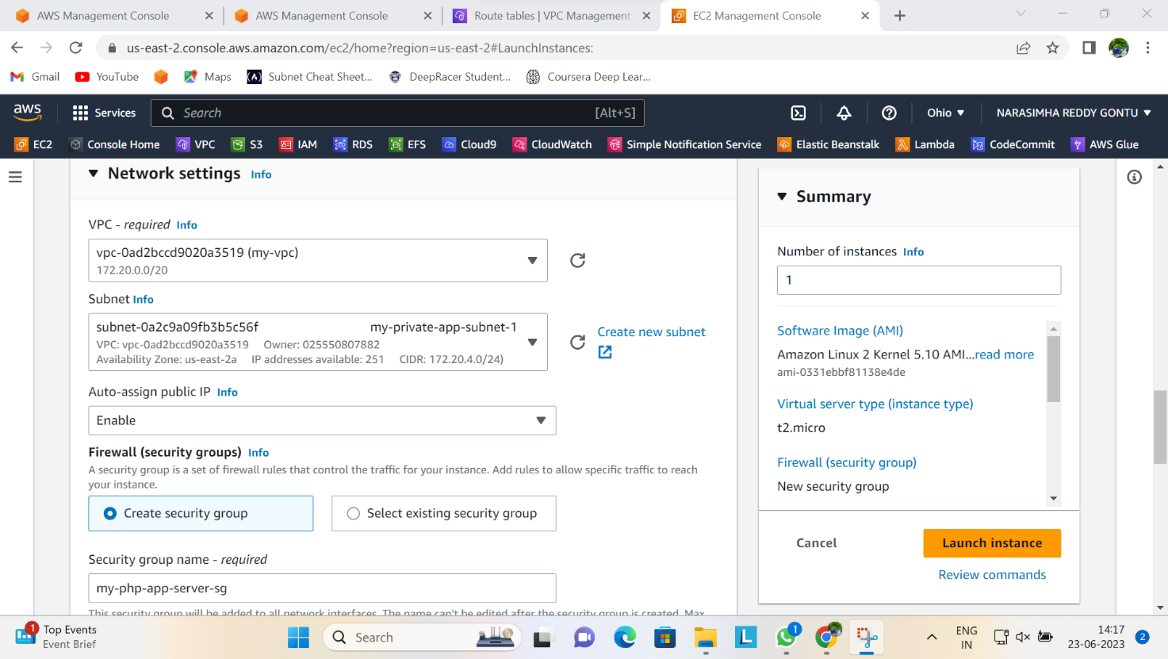

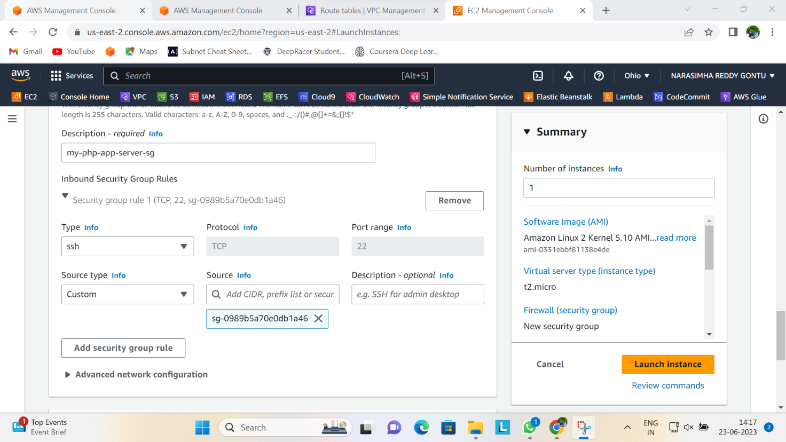

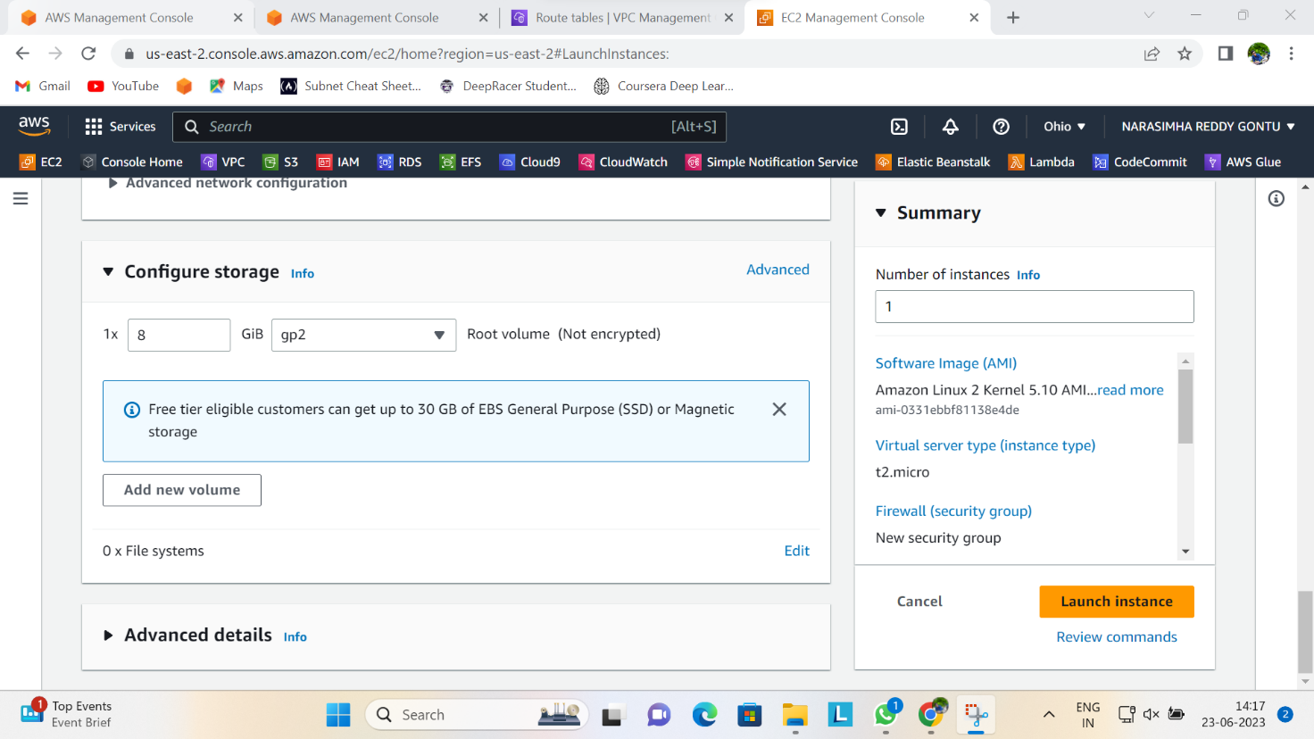

**STEP 12: CREATE 2 EC2 INSTANCES FOR YOUR APPLICATION SERVER (PHP)**

**How to create your application instance:**

Follow the steps in step 10 to create an instance but below are the parameters you will choose differently this time.

* Create it in the private app subnet 1 in the different availability zone
* Don’t enable "auto assign public ip address".
* Create a security group with SSH port 22 enabled and then select your source as the web server security group created initially.

**Create the second instance of your application server (PHP)**

Follow similar configuration but have a look at what you should do differently.

* Select Private app subnet 2
* Don't create a new security group, add the security group used for the first application server as in step 12

***Confirmation***

* If all the servers are in a running state now, proceed to the next step.

**STEP 13: USE SSH CONNECTION TO CONNECT TO THE WEB SERVER**

* Open the instance you created in the private subnet and copy the public IP address. If you use putty as your ssh client, open it and have a look at the image below to guide you on how to connect.

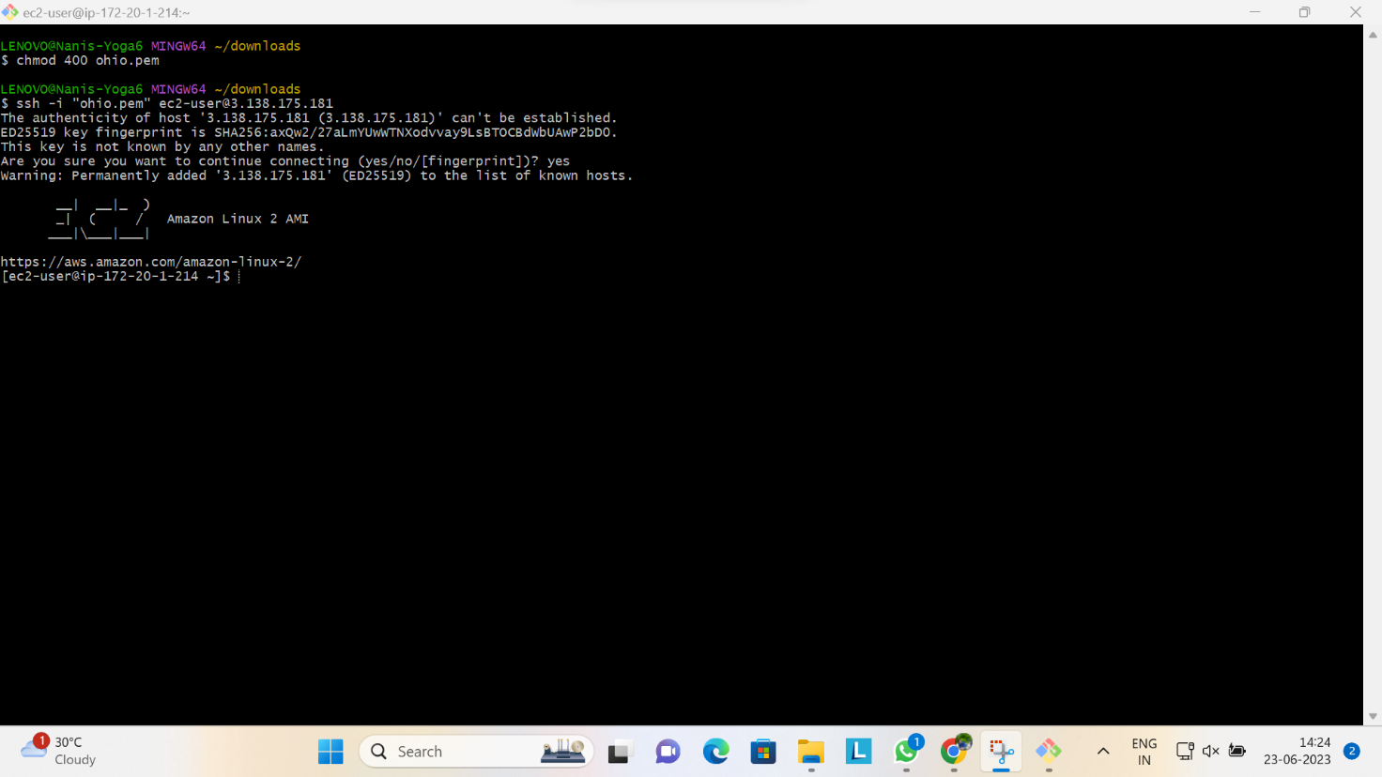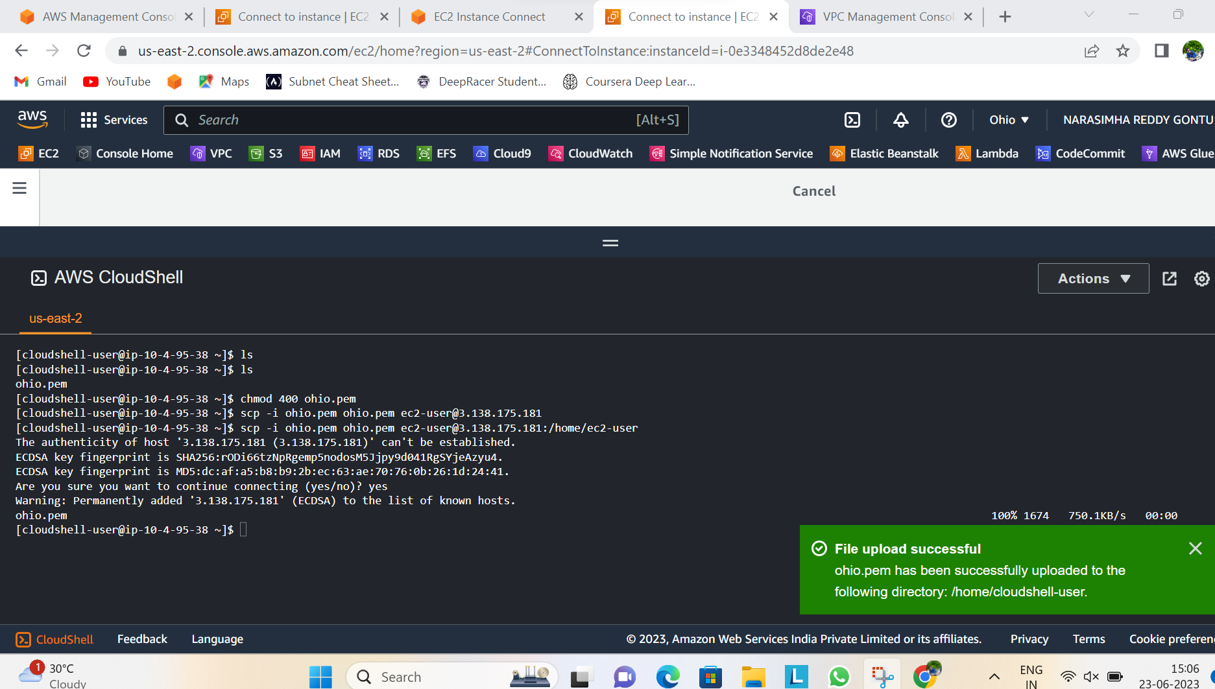

**STEP 13: CONNECT TO YOUR APPLICATION SERVER IN A PRIVATE SUBNET FROM THE WEB SERVER**

So basically, what we are trying to achieve here is to SSH into the application layer via the web server. To achieve this, go to the second instance you created on the console, and copy the private IP address.

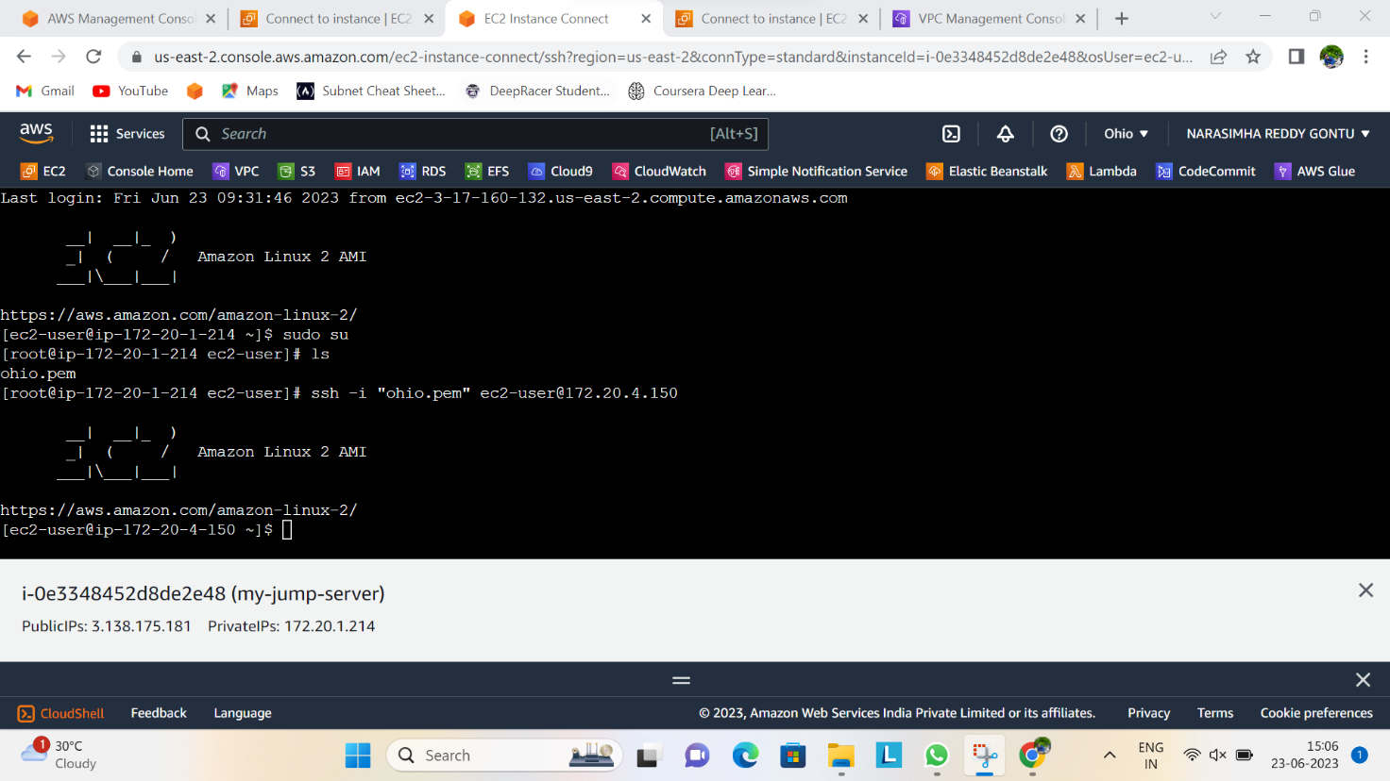

**STEP 14: INSTALL PHP AND APACHE IN THE APPLICATION SERVER**

Kindly refer to the documentation below:

<https://docs.aws.amazon.com/AWSEC2/latest/UserGuide/ec2-lamp-amazon-linux-2.html>

That is where you can get the commands for the installation. Though I'm kind enough to list the necessary commands you have to run in order to install PHP and Apache :)

To ensure that all of your software packages are up to date, perform a quick software update on your instance. This process may take a few minutes, but it is important to make sure that you have the latest security updates and bug fixes.

The -y option installs the updates without asking for confirmation. If you would like to examine the updates before installing, you can omit this option.

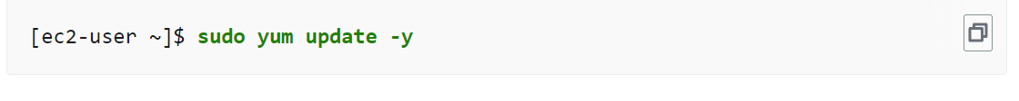

Install the lamp-mariadb10.2-php7.2 and php7.2 Amazon Linux Extras repositories to get the latest versions of the LAMP MariaDB and PHP packages for Amazon Linux 2.

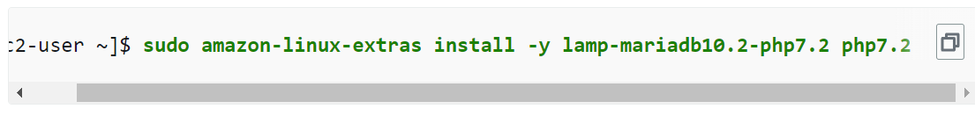

Now that your instance is current, you can install the Apache web server, MariaDB, and PHP software packages.

Use the **yum install** command to install multiple software packages and all related dependencies at the same time.



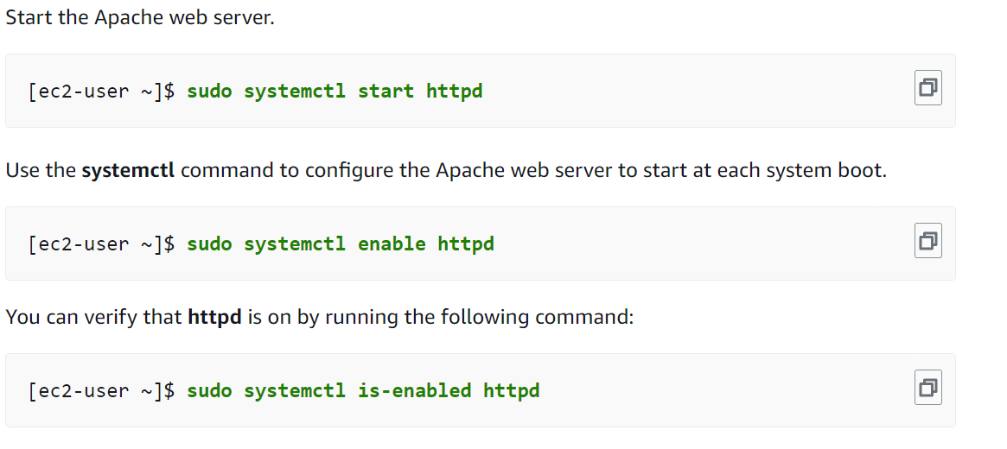

Use the command below to confirm if https service is running:

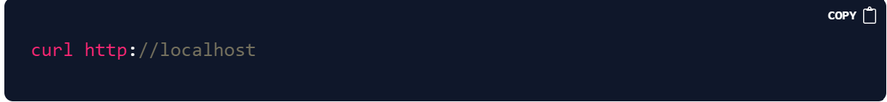

Apache **httpd** serves files that are kept in a directory called the Apache document root. The Amazon Linux Apache document root is /var/www/html, which by default is owned by root.

To allow the ec2-user account to manipulate files in this directory, you must modify the ownership and permissions of the directory. There are many ways to accomplish this task. In this tutorial, you add ec2-user to the Apache group, to give the Apache group ownership of the /var/www directory and assign write permissions to the group.

**To set file permissions**

1. Add your user (in this case, ec2-user) to the Apache group.



1. Log out and then log back in again to pick up the new group, and then verify your membership.
2. Log out (use the **exit** command or close the terminal window):



1. To verify your membership in the apache group, reconnect to your instance and

then run the following command:

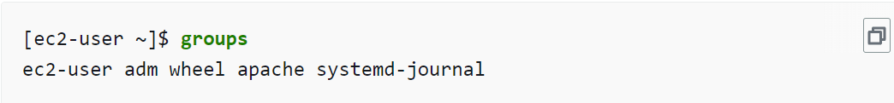

1. Change the group ownership of /var/www and its contents to the apache group.



1. To add group, write permissions and to set the group ID on future subdirectories, change the directory permissions of /var/www and its subdirectories.



1. To add group, write permissions, recursively change the file permissions of /var/www and its subdirectories:



###### To install phpMyAdmin

1. Install the required dependencies.



1. Restart Apache.



1. Restart php-fpm.



1. Navigate to the Apache document root at /var/www/html.



1. Select a source package for the latest phpMyAdmin release from <https://www.phpmyadmin.net/downloads>. To download the file directly to your instance, copy the link and paste it into a **wget** command, as in this example:

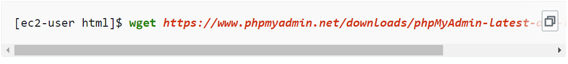

1. Create a phpMyAdmin folder and extract the package into it with the following command.

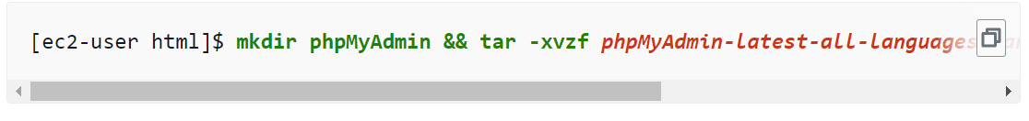

1. Delete the phpMyAdmin-latest-all-languages.tar.gz tarball.



**STEP 15. CREATE A LOAD BALANCER FOR THE APPLICATION**

When creating a load balancer in AWS management console, follow these steps and take note of the parameters you should use.

* It should be internet facing because you have to expose it to the outside world
* Select the VPC you created
* In availability zone, select at least 2 public subnets
* Create a security group and assign port 80 in the port range, select TCP protocol and make the source 0.0.0.0/0.
* At the listener section, Create a target group
* Register the target by selecting the 2nd application servers or instances you created, then select **include as pending below** as shown in the image below and then click on **create target group**

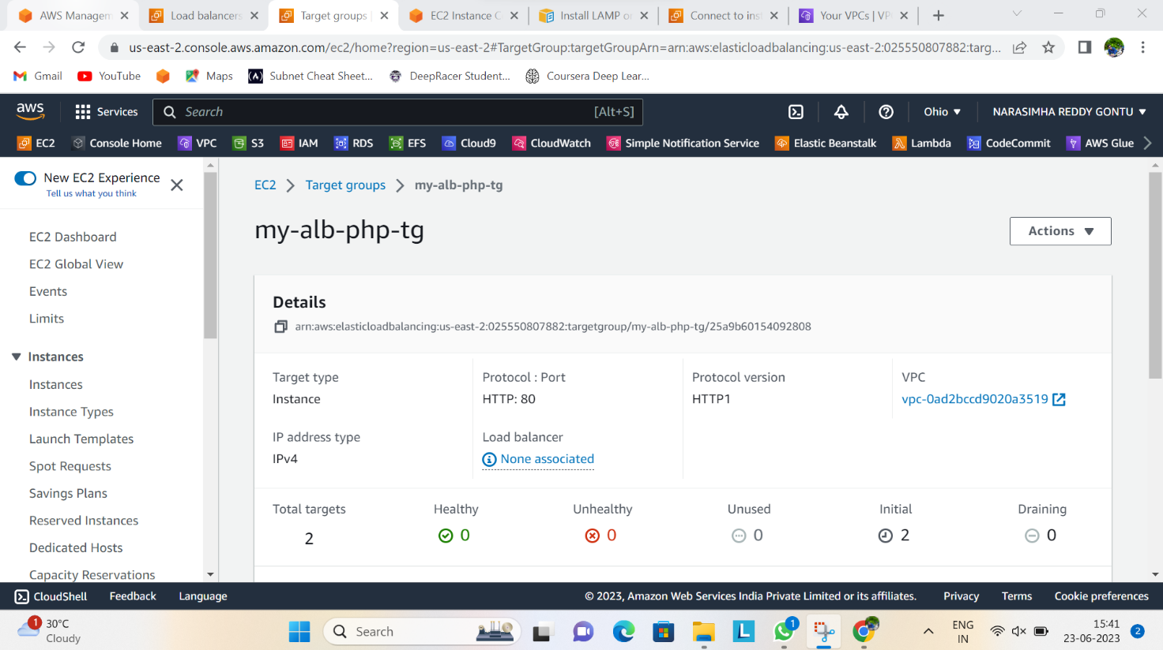

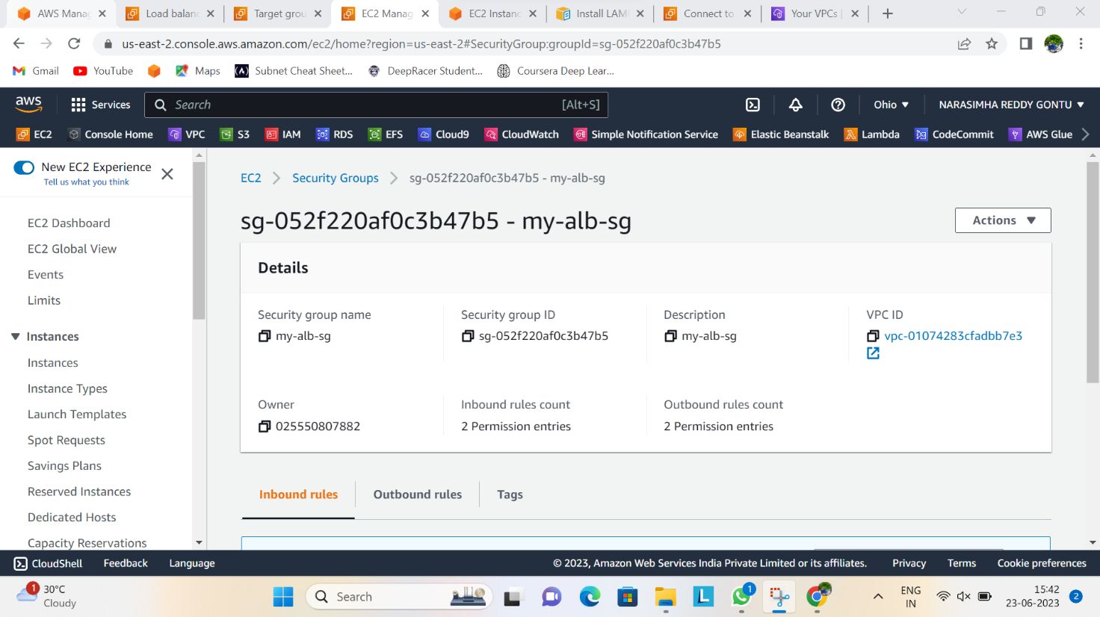

Go back to finish up with the creation of your load balancer. Select the target group created and **create the load balancer**

Now check to see if the instances in your target groups are healthy or not. Even if it is still at initial stage, you can proceed to the next step

**STEP 16. ALLOW THE LOAD BALANCER SECURITY GROUP IN YOUR APPLICATION SERVER SECURITY GROUP.**

You need to do this in order to establish connectivity between your load balancer and your instances

* Open the first Application Server/instance and click on **edit inbound rule**
* Choose the same security group you have for your load balancer. Protocol should be TCP in port 80

**STEP 17: TEST THE LOAD BALANCER ON THE BROWSER**

* Open your load balancer and copy the load balancer DNS URL and paste it on the browser.

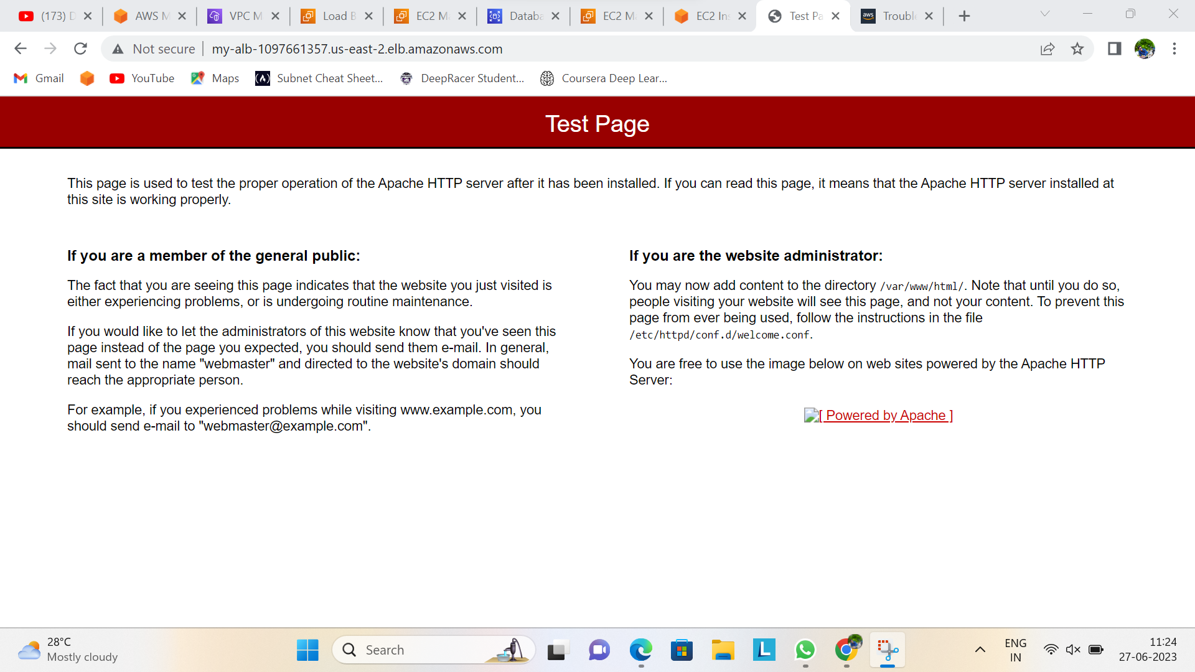

Also check to see if the load balancing is functioning as expected. From the terminal, change directory using the command below:

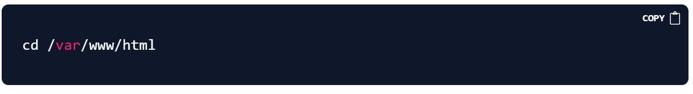

So, for you to validate if both requests are going to the app servers, run the command:

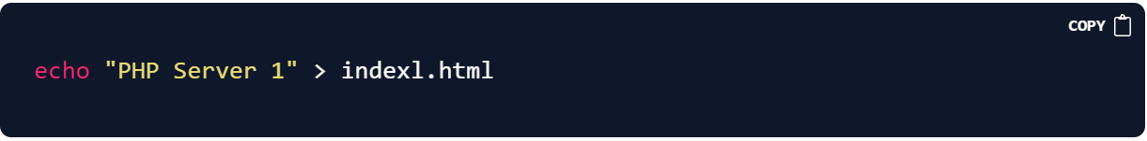

Then navigate to your browser and at the end of the web address url (still using the DNS URL of your load balancer), type /index.html and press enter.

This page will display as shown below

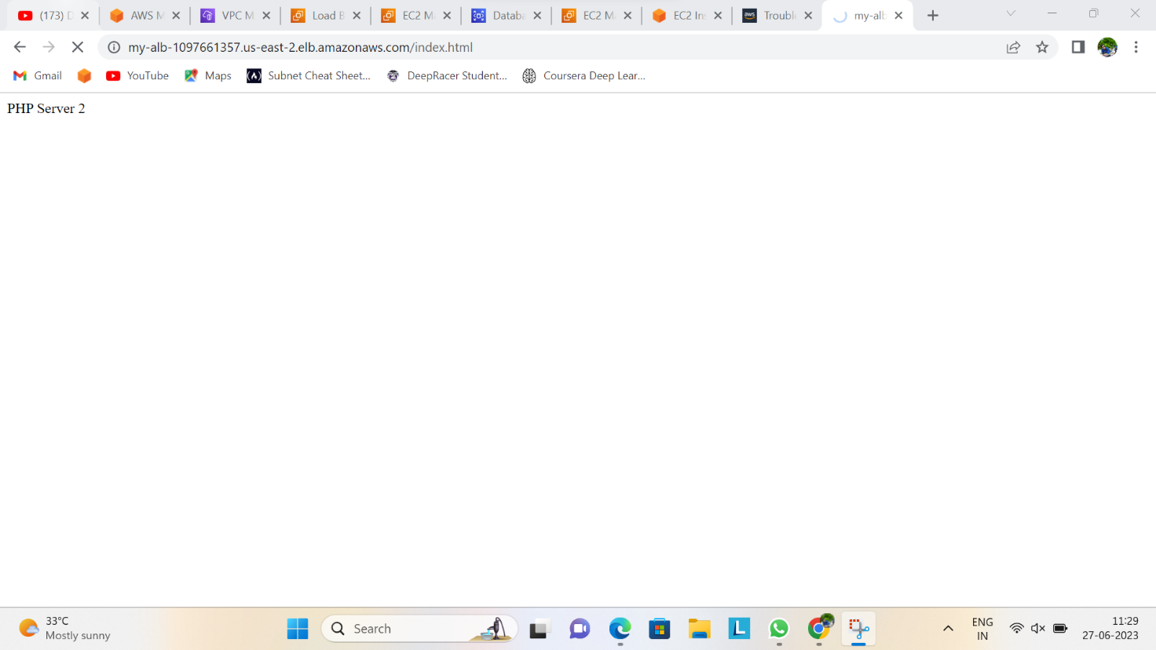

This shows it can route requests to the application server 2

**STEP 18: CREATE A DATABASE**

Before you proceed with database creation, first create a subnet group. This will allow you to select the subnets you have created for the database.

* To create, navigate to RDB service and click on subnet group, click on **Create DB subnet group**
* Select your VPC
* Select at least 2 availability zones and 2 subnets you have created for your Database. Click on create

**Now create the database (MySQL)**

* From the RDS service, click on **create database**, select **MySQL**
* Select free tier
* Type the database name and password
* Select instance type
* Choose your VPC
* Create a security group for your database
* Select at least one availability zone
* Create your database

Once it has been created, you need to enable the connectivity between the app server and security group.

Go to the security group you’re of database and **edit inbound rule**

You should add 3306 as the database port and select your app server security group, the security group is the one you created for your application server, remember? see mine below to guide you

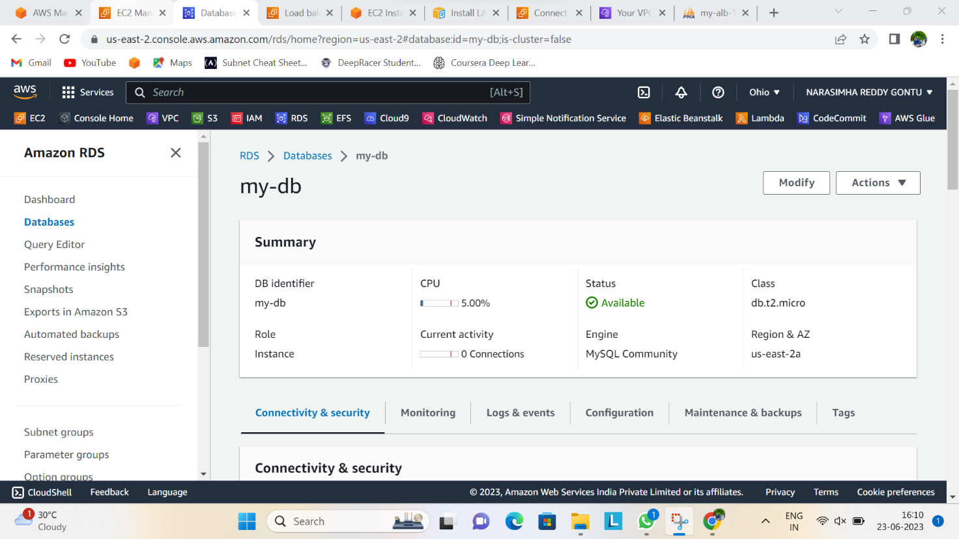

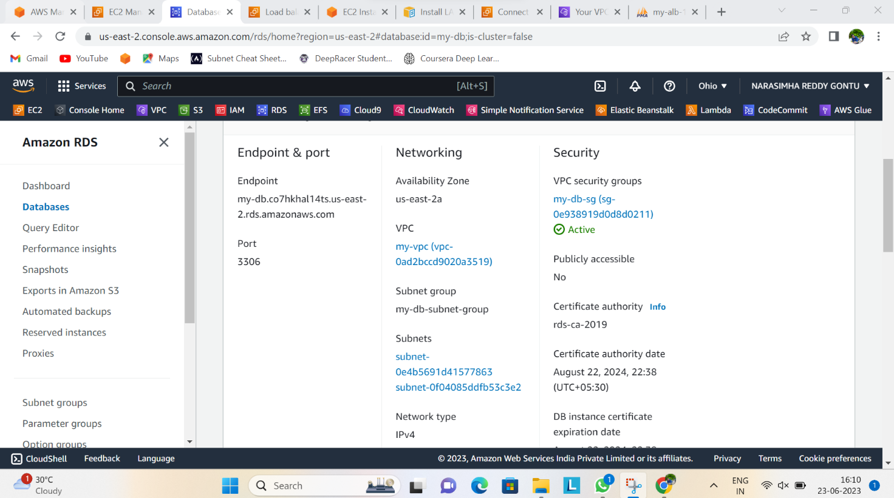

Next thing you should is to copy the database endpoint, go back to your terminal and run the command below in the PHP server (application server).

In order to execute that, change directory to phpMyAdmin folder with

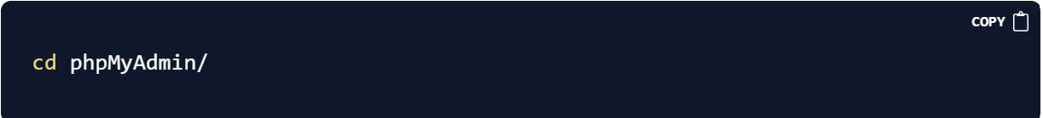

Rename the file from config.sample.inc.php to config.inc.php with the command below:

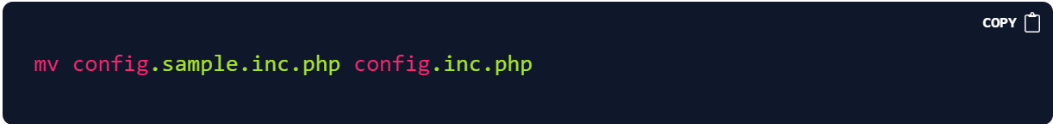

Now open the file

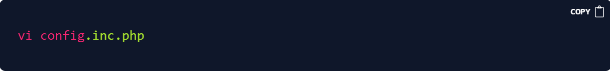

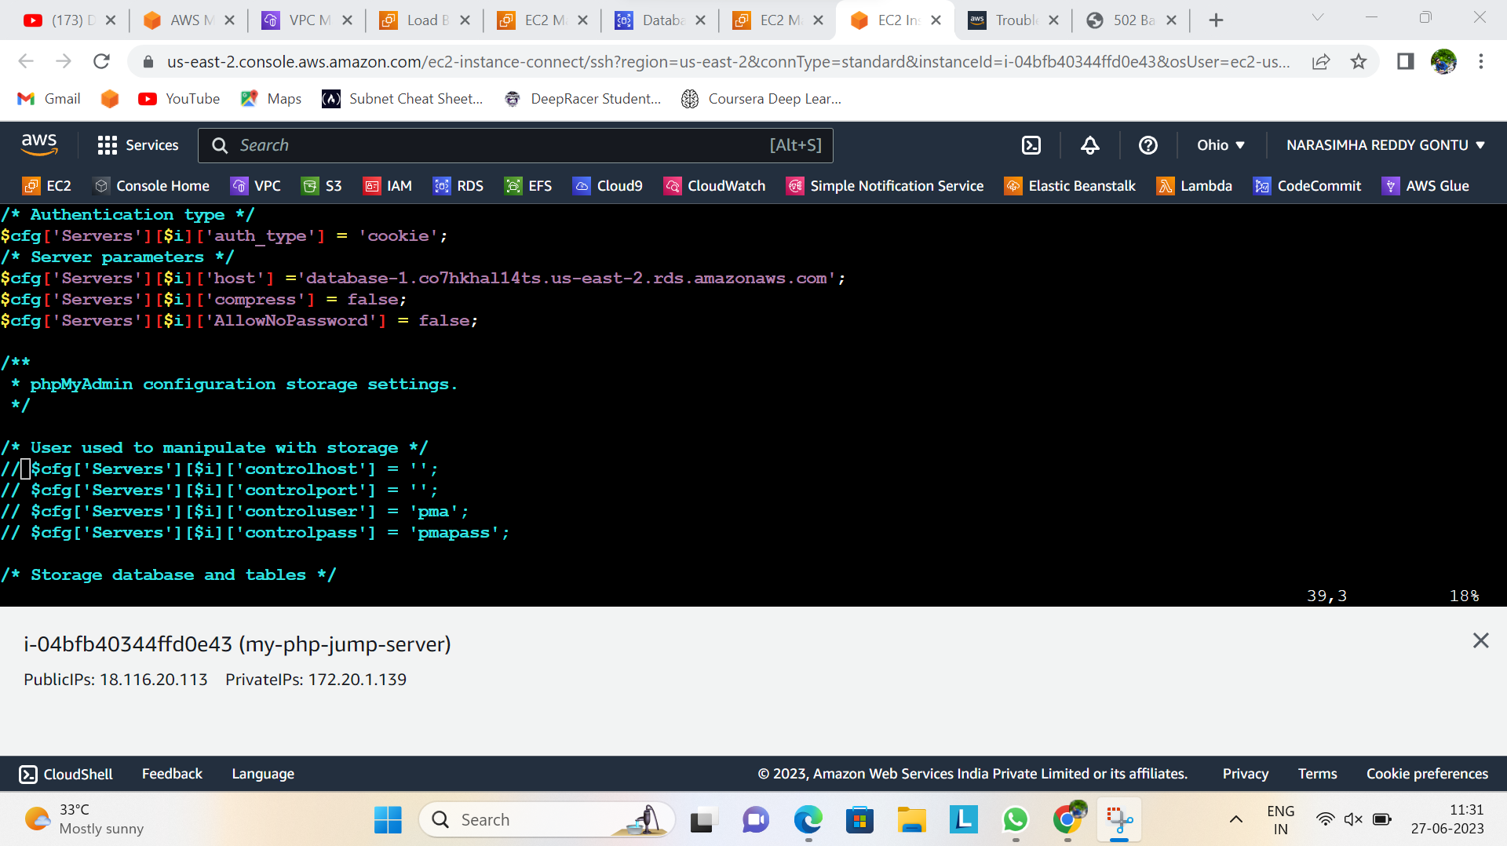

Now that the file is open in your text editor, scroll down all the way in search of localhost, once located replace the localhost with the database endpoint you copied from the console after you created the database and then save the file.

**STEP 19: TEST YOUR APPLICATION**

Still using the load balancer DNS URL on the browser, replace the index.html you added at the end of the URL with phpMyAdmin and press enter.

Your PHP page should be displaying as shown below:

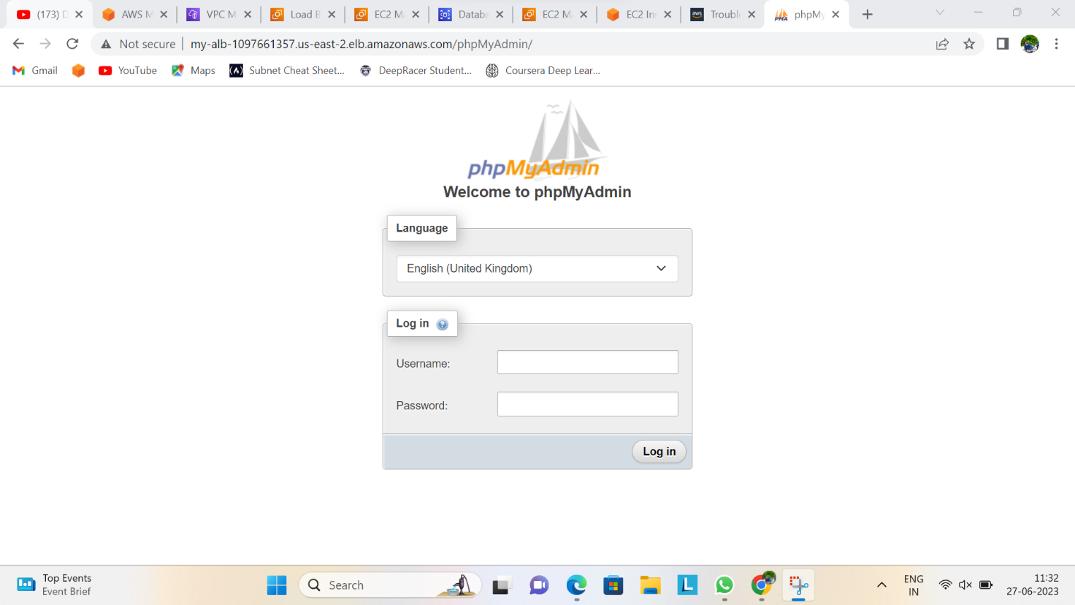

If you try to login in and click on "GO"

You will see error displayed as seen in the image of my php page above

To resolve it, go target group, select your target group, navigate to the attribute tab, click on **Edit option** to enable **stickiness**under load balancing algorithm.

Having done this, your request will flow in one server and in case of failure, it will be redirected to the other server